A Lesson in Diabetes
http://www.youtube.com/watch?v=jHlbWAnWsGY
http://www.youtube.com/watch?v=ldFYfNrIVRI

Data Analysis
Using the following data, make a line graph to illustrate the trend of a national epidemic. Be sure to title your graph and label the X and Y axes.
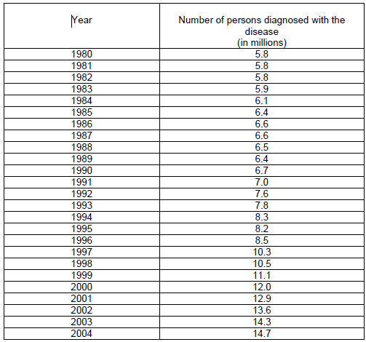
Using the following data, make a line graph to illustrate the trend of another national epidemic. Be sure to title your graph and label the X and Y axes.
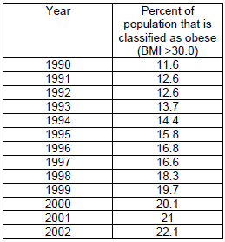

Conclusions
- Taking a look at your graphs, do you believe there is a correlation between BMI and the occurrence of diabetes?
- Is BMI the only contributing factor to the occurrence of diabetes in humans?
- Our data ends at 2004. Make a prediction of how many people you believe have been diagnosed with diabetes in 2013. Do you believe there is a correlation between BMI and diabetes in 2013? Why or why not (please provide me with a thorough explanation!)

