Name ______________________________________________________ date________ block_____

Acceleration POGIL
Learning targets
1. Define acceleration
2. Describe the difference between velocity and acceleration
3. Describe when an object is accelerating
4. Calculate acceleration

To answer the question "How do things move?" we can provide the velocity of an object, which tells us how fast an object is moving and in what direction. But what if the velocity is changing? This is what acceleration describes - how quickly the velocity of an object is changing. In this POGIL we will learn about when an object is accelerating and how to calculate the rate of acceleration. Together with your group, carefully read the information given in each section and answer the questions that follow.

Examples of Acceleration
The following motions describe objects that are NOT accelerating:

• A bird flies at a constant speed of 10 m/s in a constant direction of north
• A train travels at a constant velocity of 45 mi/h south
• A car travels along a straight section of highway at a constant 100 km/h

The following motions describe objects that are accelerating:

• A bird, flying at a speed of 5 m/s, speeds up to 10 m/s in a constant direction of north
• A person runs at a constant 3 mi/h while turning from the north to the east
• A car travels along a curve while slowing down to 60 km/h from 100 km/h

- What are two ways that an object can accelerate?

2. Below are several descriptions of motion. For each one, state whether or not the object is accelerating and explain your answer.
a) A sprinter runs a race on a straight track starting from rest and reaches a top speed of 10 m/s

b) A race car travels along a straight section of a race track at a constant 90 m/s

c) A cyclist travels around a curve at a constant 13 m/s

d) A train moving at 20 km/h comes to a stop at a station along a straight section of track.

3. For each of the following descriptions of motion, state whether the description indicates a position,
speed, a velocity, or acceleration.
a) A cat can run up to 13 m/s

b) We are located at the corner of 3rd Street and Main Street.

c) An airplane is moving west at 200 km/h

d) The 100 mi trip took 2 h

e) A drag racer, starting from rest, reaches a speed of 100 mi/h in 4 s

f) A person is at rest.

g) A cyclist went from traveling at 15 m/s north to 15 m/s east in 20 s

Acceleration
Acceleration is the rate of change of velocity during sometime interval. It tells us how quickly the velocity is changing. Note that it does NOT tell you how fast an object is moving.

We can easily calculate acceleration for objects moving in one direction. Suppose a car traveling at 10
m/s speeds up to 25 m/s in 5 s. To find the acceleration we do the following:

Acceleration = change in velocity = v_{f} – v_{i} = 25m/s – 10m/s = 3m/s²
Time t 5 s

acceleration =

v_{f}− vi 25 m / s − 10 m / s

 3m / s / s  3m

time t 5s

This means that, on average, the velocity of the car increased by 3 m/s each second. The car may not have changed its velocity by exactly this amount each second; remember that it is an average. The units of acceleration may also be written as 3 m/s2.

As a second example, suppose a car traveling at 30 m/s comes to a stop in 6 s. The average
acceleration rate would be:

Acceleration = change in velocity = v_{f} – v_{i} = 0m/s – 30m/s = -5m/s²
__________________________ ________ ____________________
Time t 6 s

acceleration = change in velocity

v − vi 0 m / s − 30 m / s


 −5 m / s / s  −5 m
t 6s

This means that, on average, the car reduced its velocity by 5 m/s each second. This could also be written as -5m/sec²

4. What is the difference between velocity and acceleration?

5. Calculate the acceleration in each of the following cases. Show all your work.
a) A sprinter, starting from rest, reaches a top speed of 10 m/s in 5 s

b) A truck on the highway speeds up to 30 m/s from 10 m/s in 30 s

c) A truck traveling at 30 m/s slams on its brakes and stops in 4 s

d) A car moving at 40 m/s slows down to 25 m/s in 15 s

e) A long-distance runner moves at a constant velocity of 5 m/s for 100 s

f) A car accelerates from a standstill to 60 m/s in 10 seconds.

g) A roller coaster's velocity at the top of a hill is 10 m/s. Two seconds later it reaches the bottom
of the hill with a velocity of 26 m/s.

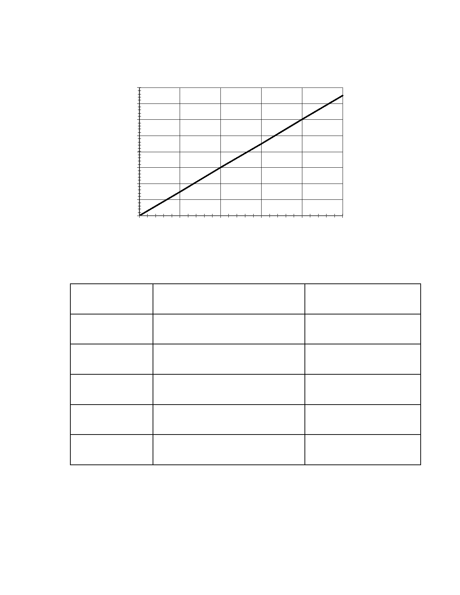
Problem Solving
velocity (m/s)
6. The graph below shows the velocity vs. time graph for an airplane taking off from a runway.
Answer the questions that follow based on this graph.

80

70

60

50

40

30

20

10

0
0 10 20 30 40 50
time (s)

a) Calculate the average acceleration rate of the airplane during the time intervals in the
following chart. Hint: Calculate the slope using rise/run.

Time Interval (s)

0 to 10

10 to 20

20 to 30

30 to 40

40 to 50

S l op e

Acceleration (m/s2)

b) Is this an example of motion at constant velocity? Why or why not?

c) Is this an example of motion at constant acceleration? Why or why not?

