Earthquakes in the middle of ocean?
Name_____________________________________________Date________________Period___________

Background Information: In your previous activity, you discovered that crustal activity occurs in patterns. In other words, earthquakes, volcanoes, and mountains are not random events. They only occur in specific places. When looking at patterns of crustal activity, it appears that the surface of Earth is divided into pieces or plates. In this activity, you are going to investigate one of the locations where crustal activity is abundant. There is a lot of crustal activity in the middle of the Atlantic Ocean. Why? What is going on there? Today, you are going to collect and analyze 3 sets of data from the Atlantic Ocean seafloor. After analyzing your data, you should be able to form a conclusion about what causes the crustal activity in the middle of the Atlantic Ocean floor.

Objective: Develop a theory that determines why there is crustal activity in the middle of the Atlantic Ocean by analyzing the following data sets:
  - Depth vs Location (east to west)
  - Age vs Location (east to west)
  - Polarity vs Location (east to west)

Outcomes:
- Your data analysis (graphs) - 20 points
- Conclusion – 10 points
  - This is your theory that explains why there is crustal activity in the middle of the Atlantic Ocean.

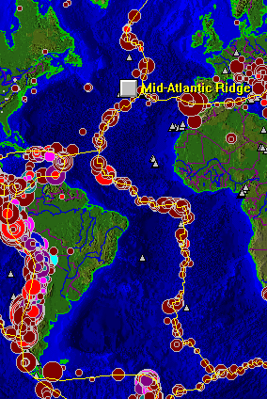

Data Table: North Atlantic Ocean Bottom Profile

Distance from East Coast  of the US (km) | Depth (km)
0 | 0
120 | 0.2
200 | 2.7
400 | 3.7
490 | 3.7
620 | 4.6
680 | 1.8
720 | 4.6
2000 | 4.6
2500 | 4.0
2900 | 2.7
3000 | 1.8
3090 | 4.0
3100 | 2.4
3200 | 2.9
3500 | 3.5
3600 | 3.7
4025 | 4.0
4050 | 3.8
4100 | 3.9
4125 | 4.3
4500 | 4.6
5000 | 5.0
5300 | 4.4
5800 | 3.7
6000 | 2.7
6075 | 0.2
6100 | 0

Analysis Questions:
- Describe the shape of the Atlantic ocean seafloor
  - Where are the highest elevations?
  - Where are earthquakes located?
  - Where are volcanoes located?
  - What do you think is causing the seafloor feature in the middle of the ocean?
  - According to class discussion, label the seafloor features on your graph.

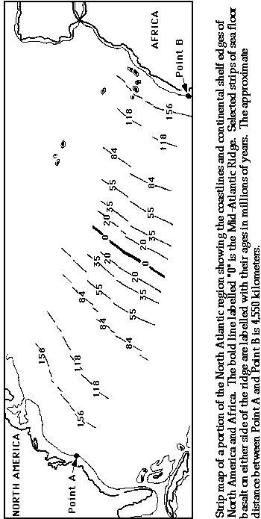

Analysis Questions:
- Where are the youngest rocks located?
- Where are the oldest rocks located?
- What is the pattern revealed in your graph?

Distance from East Coast (km) | Pole
0 | n
458 | n
753 | n
754 | r
1194 | r
1195 | n
1401 | n
1402 | r
1589 | r
1719 | r
1884 | r
2274 | r
2275 | n
2386 | n
2387 | r
2774 | r
2775 | n
2995 | n
3050 | n
3105 | n
3225 | n
3226 | r
3615 | r
3616 | n
3825 | n
3826 | r
4216 | r
4381 | r
4589 | r
4590 | n
4803 | n
4804 | r
5354 | r
5355 | n
6100 | n
Data Table: Polarity of Atlantic Ocean seafloor rocks

Analysis Questions:
- What is the pattern revealed in your graph?

