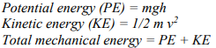
Bell Ringer 10: PE and KE Calculations
- A baby carriage is sitting at the top of a hill that is 21 m high. The carriage with the baby weighs 12 Kg. The carriage has ____________ energy. Calculate it

- A car is traveling with a velocity of 40 m/s and has a mass of 1120 kg. The car has ___________energy. Calculate it.

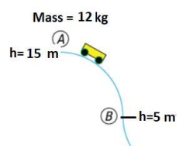
- What is the mechanical energy of the cart on the right at position A. The cart is not in motion. (height=15 m, mass = 12 kg, gravity = 10 m/s2 )?

- What is the kinetic energy when the moving cart is 2/3 the way down (height=5 m) when the total mechanical energy is _____________ (from previous question)?

TODAY
T.A.C. Sheet Unit Topic: MOTION Name _____________________________

I Am

So I Can

