1. Determine the distance and the displacement for the poor confused chicken in the diagrams below.

**Bell Ringer 1**

1. Balanced or unbalanced?
2. Calculate for net force

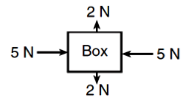

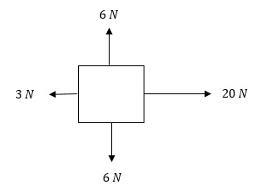

1. Balanced or unbalanced?
2. Calculate for net force

5. Create a free body diagram showing an object accelerating to the right.

**T**ODAY

**T.A.C. Sheet Unit Topic**: **MOTION** Name _____________________________

 I **A**m

So I **C**an