Bell Ringer 2: Forms of Energy
Directions: Determine the type of energy for each form (Kinetic or Potential)
and give an example NOT found on your notes sheet!
_____1. Lightening

_____2. Release of energy from the sun

_____3. Batteries

_____4. Energy that runs a refrigerator

Directions: Match the energy form(s) to the description provided.
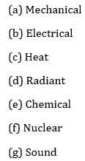

Form | Type (KE or PE) | Example
Motion energy
Thermal (heat) energy
Radiant energy
Electrical energy
Chemical energy
Nuclear energy
Sound energy
Gravitational energy
_____5. Nuclear fission reactions _____7. Energy in food before it is eaten

_____6. Ruble of thunder from a storm _____8. Gasoline

TODAY
T.A.C. Sheet Unit Topic: MOTION Name _____________________________

I Am

So I Can

