Bell Ringer 3 FINAL REVIEW Day 1
3. A stationary camera takes pictures of a falling ball at equal time intervals. Draw a motion map that represents the motion of the ball as it falls?
1.Explain the motion represented by each motion map below.

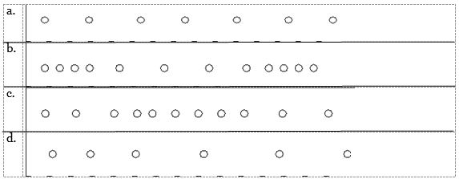
4. Explain what this graph is tells you about the velocity of the object.
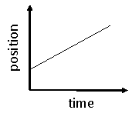
2. The Earth has a speed of 108,064.5 km/hr around the sun. The planet Mars has a speed of 86,868 km/hr around the sun. Sketch one speed vs. time graph showing the speeds of mars and Earths.

Below is Lenny’s path he takes every day from home to the playground. He loves his new Jordan’s and doesn’t want to scuff them so ONLY walks on the sidewalk. (1 sidewalk cube = 1m.)
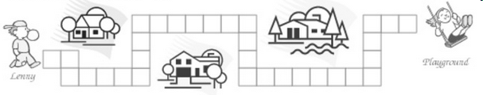
7. 7. Calculate the total distance Lenny walks every day from his house to the playground.

22. 8. Calculate the displacement between Lenny’s house and the playground.

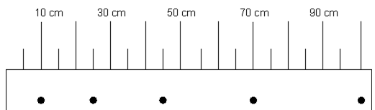
5. Describe the motion of the object above.

6. Calculate for the speed of the object between 70cm and 100cm. There is 2 seconds between these two points

