Directions: Use the figures on the left to answer the questions on the right.
Bell Ringer 4: 2017 KY Energy Data
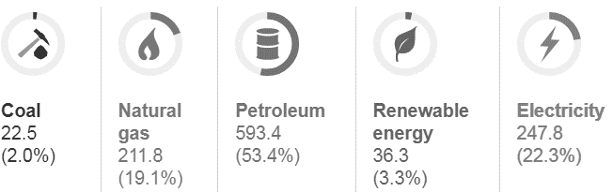
- What type of energy does KY use the most of?

- Is this a renewable or nonrenewable source?

- From what source of energy does KY get most of its electricity from?

- Is this a renewable or nonrenewable source?

- For what is most of the energy being consumed in KY used for?

- Why is this important?
Figure 1. KY Energy Consumptions

Figure 2. Sources of KY Electricity

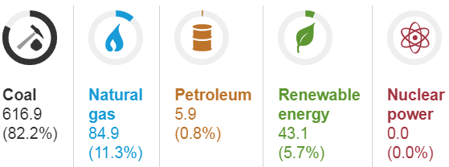

Figure 3. KY Energy Users

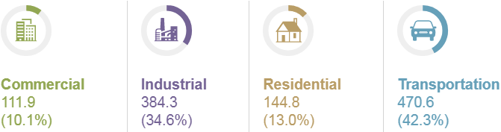

TODAY
T.A.C. Sheet Unit Topic: MOTION Name _____________________________

I Am

So I Can

