Characteristics of Life Mnemonic Creation

You have all seen and used mnemonic devices before. These are tools to help you remember a string of words. Some examples can be seen below:
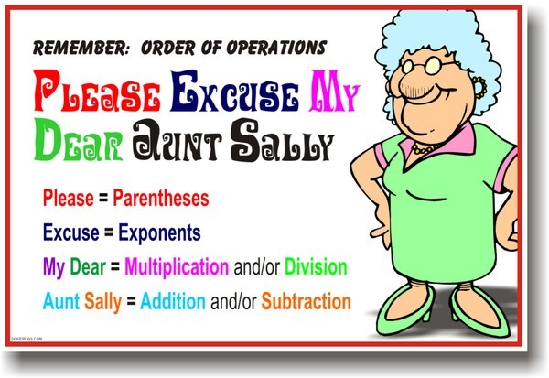

Using the Characteristics of Life that you just wrote down, create a mnemonic device to help you remember them. Your FINAL draft must be done on white computer paper. Your final must be colorful, contain pictures, and must have your completed mnemonic on it. Below is the rubric.

Requirement | Total Possible Points
All 8 characteristics have been used | 8
Mnemonic makes sense | 5
Final draft is organized and neat | 5
Colorful | 5
Contains pictures | 5
TOTAL | 28pts

