Conservation of Energy BELL RINGER
Name:

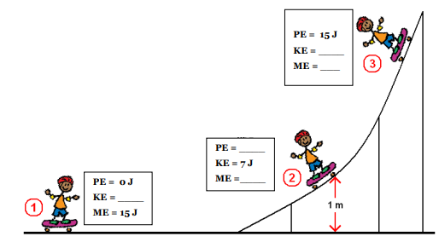
- Fill in the missing values

- A 1.8 kg book has been dropped from the top of the football stadium. Its speed is 4.8 m/s when it is 2.9 meters above the ground. What is its mechanical energy?

Conservation of Energy BELL RINGER
Name:

- Fill in the missing values

A 1.8 kg book has been dropped from the top of the football stadium. Its speed is 4.8 m/s when it is 2.9 meters above the ground. What is its mechanical

