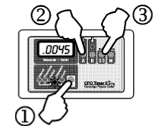
Intro Lab: How to Use the Equipment
Part 1. Using the Timer as a stop watch
- Set the timer to stopwatch.
- Start and stop the stopwatch with the “A” button.
- Reset the stopwatch to zero with the “O” button
Activity: Time how long one member of your group can hold their breathe using the CPO stopwatch you just learned how to use. Complete 3 trials and fill in the data table below. You will also need to take the average.
Name | Trial 1 Time | Trial 2 Time | Trial 3 Time | Average Time

Part 2. Using the photogates
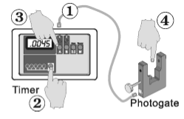
A photogate allows us to use a light beam to start and stop the timer. When the timer is in interval mode, it uses photogates to control the clock.
- Connect a single photogate to the “A” input with a cord.
- Select “interval” on the timer.
- Push the “A” button and the “A” light should come o and stay on.
- Try blocking the light beam with your finger and observe what happens to the timer.
Activity: Use the photogate system you just learned how to use to answer the questions below:
- Exactly what do you do to start and stop the clock? (Be very specific)

- If you block the light beam several times in a row, does the time add or does the timer start at zero every time you break the beam? How do you know this?

Part 3. Using the timer with TWO photogates
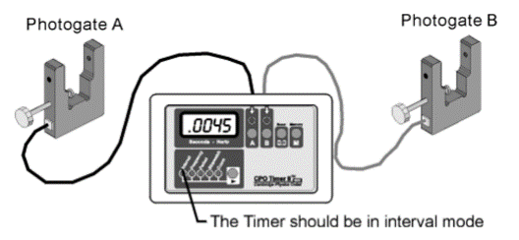
You can connect two photogates to the timer in interval mode. The second photogate connects behind the “B” light. Notice that the “A” and “B” buttons turn the “A” and “B” lights on and off.

Activity: Conduct experiments to determine what stops and starts the stopwatch for each of the different combinations of lights. Answer the questions below:
- What starts and stops the time when only the “A” light is on?

- What starts and stops the timer when only the “B” light is on?

- What starts and stops the timer when both “A” and “B” lights are on?

- What happens if you go through photogate A once and through B multiple times? (When answering this question, you might want to think about a race where all the runners start together but you want each runner’s individual tie to finish the race.)

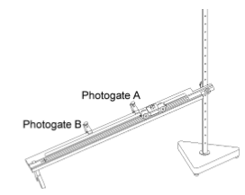
Part 3. Using the photogates with the ramps, stands, and cars.
Activity: You will be conducting an experiment to determine how the angle of the ramp affects the speed of the car.
- Setup the ramp as seen in the pictures. You will choose your beginning ramp angle (which hole in the stand you use to attach the ramp. NOTE: hole #1 at bottom of stand!)
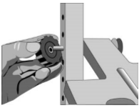
- Determine which angles you will use and write them down in the chart below.
Angle # | Hole in stand
1
2
3

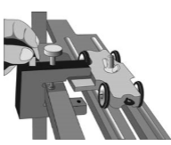
- Put two photogates on the ramps so that you can measure the time for the car. Plug the photogate closest to the top of the ramp into input A on the timer box and the other photogate into input B.

- Record the distance between the two photogates in the space below.

Distance between photogate A and B
(use the ruler markings on the ramp)

- On the timer box, make sure the “interval” button has been pushed and both the “A” and “B” lights are on.

- Place the car at the top of the ramp and let it go. Record the time in the table on the next page. Once recorded, push the “reset” button.

- Move the ramp to another angle that you already decided on. DO NOT MOVE THE PHOTOGATES!

- Repeat steps 6-7. You will then need to complete steps 6-7 for the last angle you chose.

Hole in stand number | Time from “A to B” | Speed from A to B

- To determine which angle had the greatest speed, run calculations using the equation
Speed = Δx = change in position
Δt change in time

- Your Δx will be the distance between “A” and “B” that you already measured in step 5!

- Using your data, answer the questions below.
  - Which angle created the greatest speed?

  - What could you have done to better run this experiment? (There is no such thing as a perfect experiment…we can ALWAYS do something better!!)

Group Name(s) _______________________________________ Date ______________ Block _____

