Depth Zones of the Ocean
The pelagic zone is the large portion of the ocean that is not near coastlines or continental shelves. Pelagic comes from the Greek word pélagos, which translates to “open sea.” Within the pelagic zone, the ocean can be further divided vertically. Consider a column of water that extends from the surface to the bottom of ocean basins and trenches. This column can be divided into several different zones based on depth, temperature, light, and the topography of the ocean bottom (Fig. 9.16). Since these factors vary both between and within ocean basins, depth delineations for each zone can also vary.

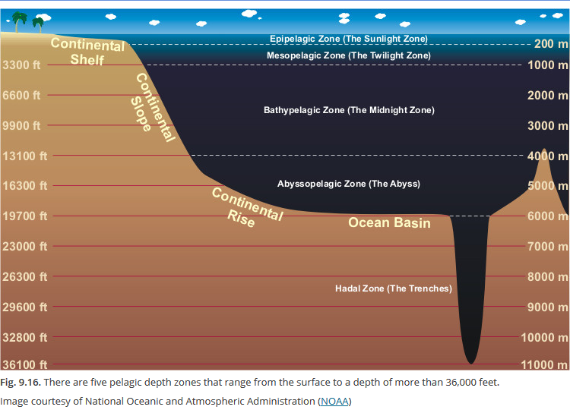
Within the well-lit euphotic zone is the epipelagic zone, which refers to the ocean surface waters that typically extend 50 to 100 meters in depth, but may be as deep as 200 meters. This zone is relatively warm because of heating from the sun and constant mixing by wind and currents. Temperatures can range from 34ºC near the equator to -2ºC near the North Pole. Since the epipelagic zone is well lit, it is home to photosynthetic organisms such as phytoplankton. Scientists can use satellites to measure the relative amount of chlorophyll (the pigment responsible for photosynthesis) in the epipelagic zone to understand how much photosynthesis is occurring (Fig. 9.17). This abundance of primary producers—compared to the rest of the depth zones—provides the base for a rich food web.

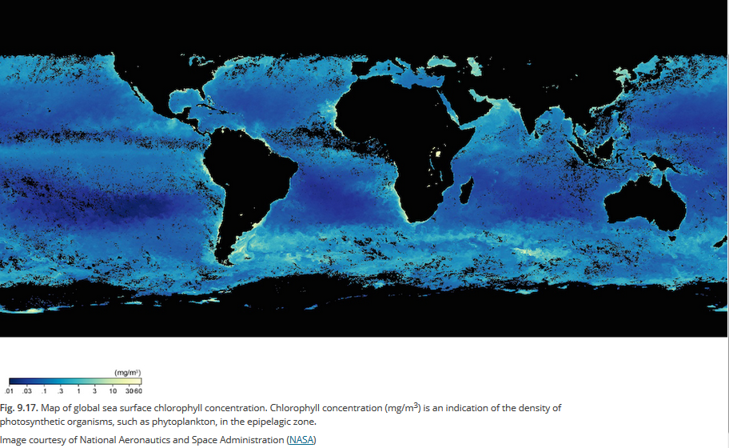
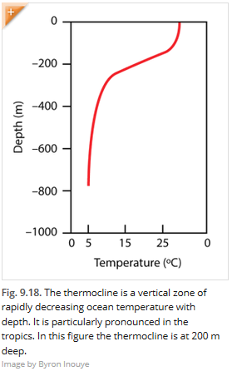
At the bottom of the epipelagic zone there is a sharp decrease in temperature known as the thermocline (Fig. 9.18). The thermocline separates the relatively warm, well-mixed surface layer from the cooler more stable water below. The start of the thermocline often indicates the upper boundary of the mesopelagic zone, or mesophotic zone. This zone is sometimes called the twilight zone because it is only dimly lit. While there is enough light for some organisms to see, there is not enough light energy for photosynthesis to occur. This zone typically extends to about 1000 meters deep.
Below the mesopelagic zone is the bathypelagic zone; this zone is also known as the midnight zone or aphotic zone because at this depth there is no light from the sun. Bioluminescent organisms produce the only light that occurs in this zone. (Fig. 9.19). The temperature in the bathypelagic zone is fairly constant 4ºC.
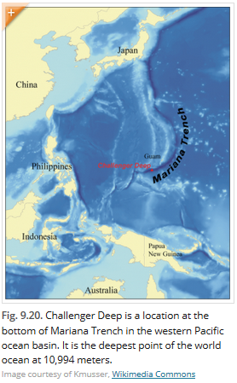
Below the mesopelagic zone is the abyssopelagic zone; in most regions of the open ocean, it is the deepest zone. This zone usually extends to the ocean bottom and, combined with the mesopelagic zone, makes up roughly 75 percent of all the ocean’s volume. This zone extends to about 6000 meters deep. The abyssopelagic zone gets its name from the Greek word abyss, which means ‘no bottom’ because people used to think the deep ocean was never ending. It has only been in recent history that humans have been able to visit and explore these deep zones.
The hadopelagic zone, or hadal zone, refers to depths below 6000 meters, which occur mostly in the deep ocean trenches. The term hadal is a reference to the Greek god of the underworld Hades. In these trenches, the temperature is just above freezing, and the water pressure is enormous. For example, the hadopelagic zone extends into the ocean’s deepest trench, the Mariana Trench, located in the western Pacific ocean basin (Fig. 9.20). The Mariana Trench has at a maximum depth of nearly 11,000 meters. At that depth, the water column above is exerting a pressure of over one thousand atmospheres.

Question Set for Depth Zones of the Ocean
- Complete the table below. Remember that for every 10 m depth, pressure increases by 1 atm.

Depth Zone | Depth (m) | Pressure Range (atm) | Average Temperature (°C) | Light Intensity
Epipelagic
Mesopelagic
Bathypelagic
Abyssopelagic
Hadopelagic

- Using the table above, create a graph of depth (on the X-axis) vs. pressure (on the Y-axis) on the graph paper provided. Label the five zones on your graph. Describe the patterns you observe in your graph.

- What factors can affect the depth of the epipelagic and the mesopelagic zones?

- Using the internet, find at least 5 marine organisms that live in each of the zones. List those below.
Depth Zone | Organisms
Epipelagic | 1.  2.  3.  4.  5.
Mesopelagic | 1.  2.  3.  4.  5.
Bathypelagic | 1.  2.  3.  4.  5.
Abyssopelagic | 1.  2.  3.  4.  5.
Hadopelagic | 1.  2.  3.  4.  5.

