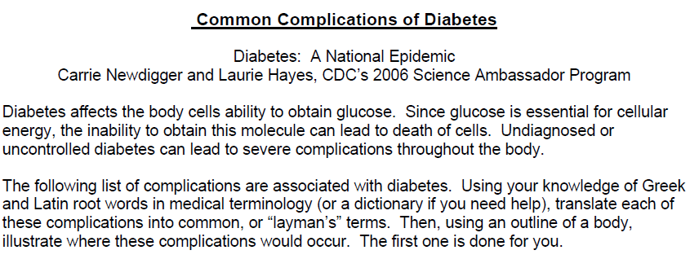

Diabetes Complication | Common Term | Area Where Complications Might Occur
Cardiovascular disease | Heart disease, leading to stroke, heart attack | Heart and vessels
Gastroparesis
Hypertension
Nephropathy
Neuropathy
Pedal Ulcers
Periodontal disease
Renal disease
Retinopathy
Urologic Problems

