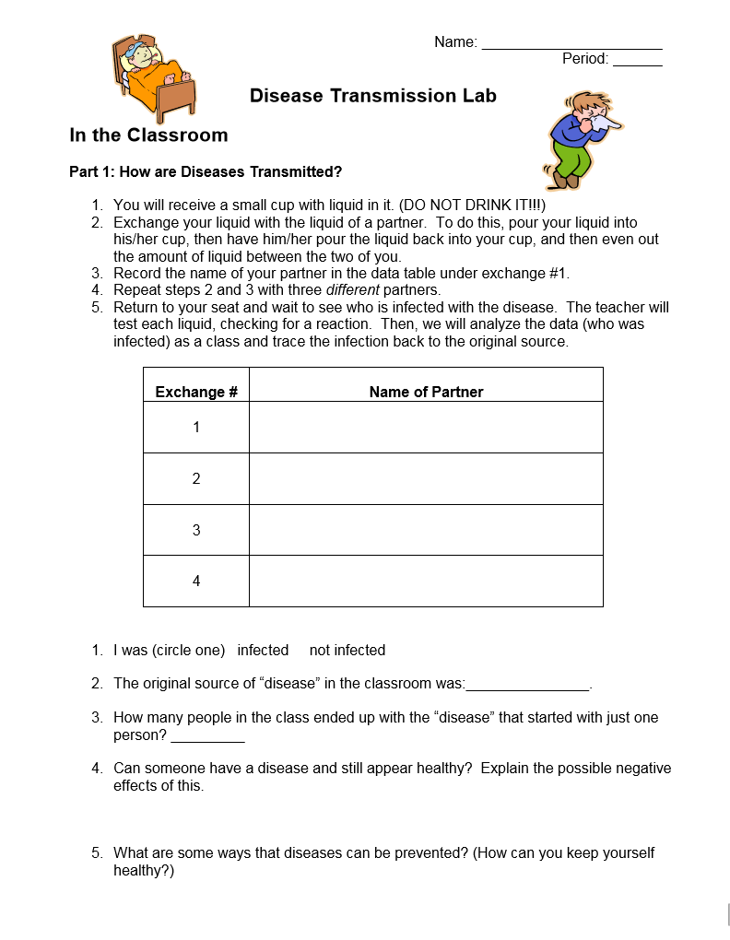
6. In the space below, make a diagram of the transmission route.
Student Name | Contact 1 | Contact 2 | Contact 3

