Bell Ringer 8/21/18
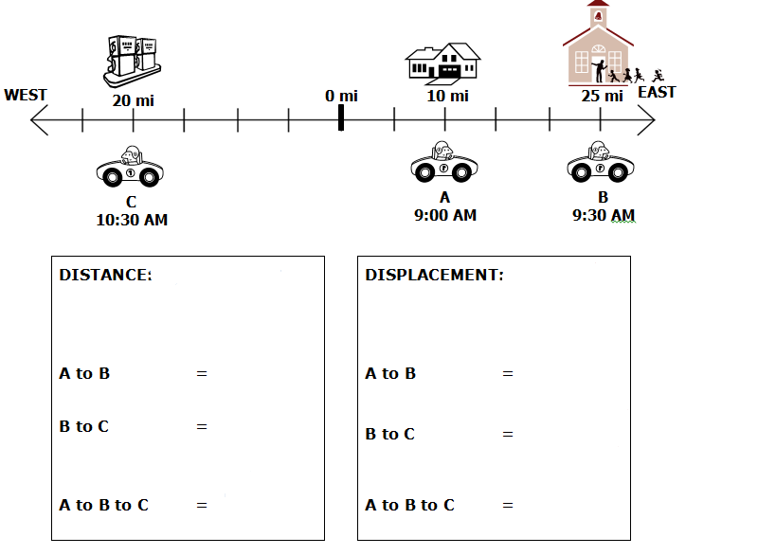

Bell Ringer 8/21/18

