Name________________________________________ Block________
Bell Ringer 8/23/18
Use the number line below to answer the following questions: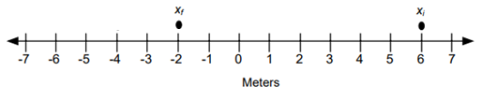
- Draw an arrow to show the displacement.
- Is the initial position positive or negative? ____________________
- Is the final position positive or negative? ____________________
- Is the displacement positive or negative? ____________________
- What is the displacement [size (with units) and direction (+ or -)]? ____________________

Name________________________________________ Block________
Bell Ringer 8/23/18
Use the number line below to answer the following questions:
- Draw an arrow to show the displacement.
- Is the initial position positive or negative? ____________________
- Is the final position positive or negative? ____________________
- Is the displacement positive or negative? ____________________
- What is the displacement [size (with units) and direction (+ or -)]? ____________________

