Distance vs. Displacement Practice
- Bessie the cow and Sally the bird both traveled from point “A” to point “B.” Sally traveled in a straight line and Bessie did not.

- What’s the distance Bessie the cow traveled?___________________
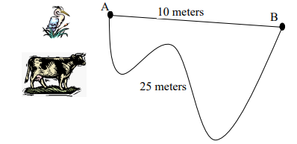
- What’s the distance Sally the bird traveled?_________________

- What is Bessie the cow’s displacement?_________________

- What is Sally the bird’s displacement?_________________

- The race track shown is 100 meters around.
- If the car travels once around the racetrack, what distance does it travel? _______________
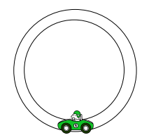
- If the car travels twice around the racetrack, what distance does it travel? ______________

- If the car travels once around the racetrack, what is its displacement? ________________

- Is the displacement below positive or negative? ____________________
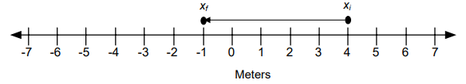

- Use the number line below to answer the following questions:
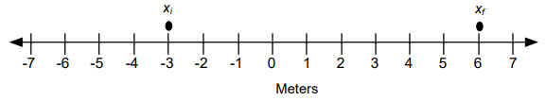
- Draw an arrow to show the displacement.
- Is the initial position positive or negative? ____________________
- Is the final position positive or negative? ____________________
- Is the displacement positive or negative? ____________________
- What is the displacement [size (with units) and direction (+ or -)]? ____________________
- Use the number line below to answer the following questions:
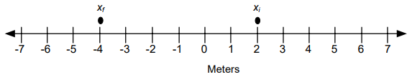
- Draw an arrow to show the displacement.
- Is the initial position positive or negative? ____________________
- Is the final position positive or negative? ____________________
- Is the displacement positive or negative? ____________________
- What is the displacement [size (with units) and direction (+ or -)]? ____________________

- Use the number line below to help answer the following questions about Freddy the cat:

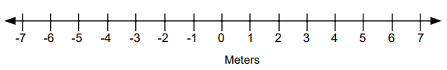
- Freddy started at the –3 m position. (mark this position with an “a”)
- First, Freddy walked 2 meters in the positive direction (right) to the –1 m position. (mark this position with an “b”)
- Second, Freddy walked 5 meters in the positive direction to the +4 m position. (mark this position with an “c”)
- Third, Freddy walked 1 meter in the negative direction to the +3 m position. (mark this position with an “d”)
- Finally, Freddy walked 8 meters in the negative direction to the –5 m position. (mark this position with an “e”)

- Draw a displacement arrow that starts at Freddy’s initial position (-3 m) and ends at Freddy’s final position (-5 m).

- What was Freddy’s total displacement (be sure to include sign, number, and units) ___________________

- What was the total distance Freddy traveled?____________________

- Is Freddy’s total displacement equal in size to Freddy’s total distance traveled?___________

