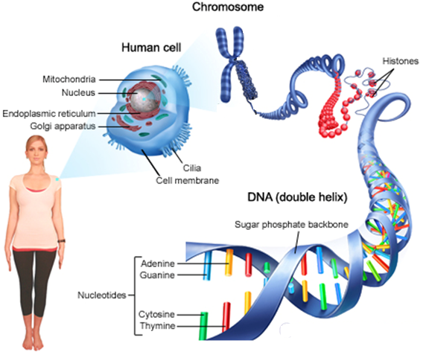

**DNA Structure**

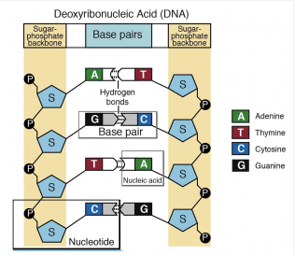

**DNA 🡪 RNA 🡪 Protein**

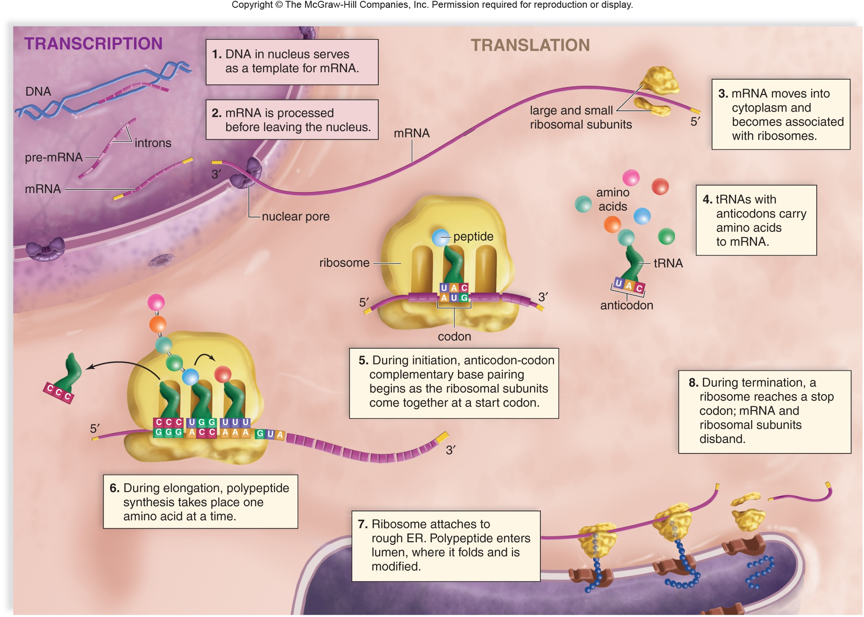

DNA vs. RNA

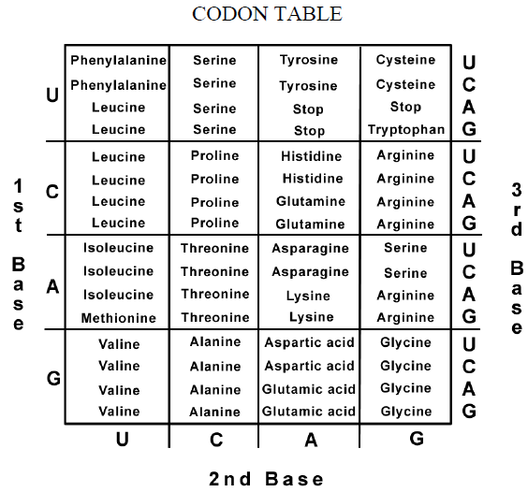

|  |  |  |
| --- | --- | --- |
|  | **DNA** | **RNA** |
| Overall Role |  |  |
| Sugars |  |  |
| Nucleotide Bases |  |  |
| Strands |  |  |

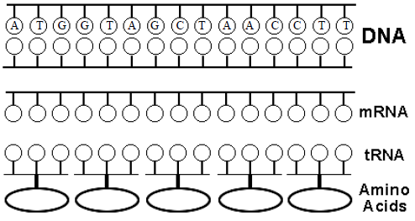

Practice