EARTHQUAKE/VOLCANO/TSUNAMI POSTER PROJECT

Name(s) ____________________________________________________
This paper AND the poster are both worth points!

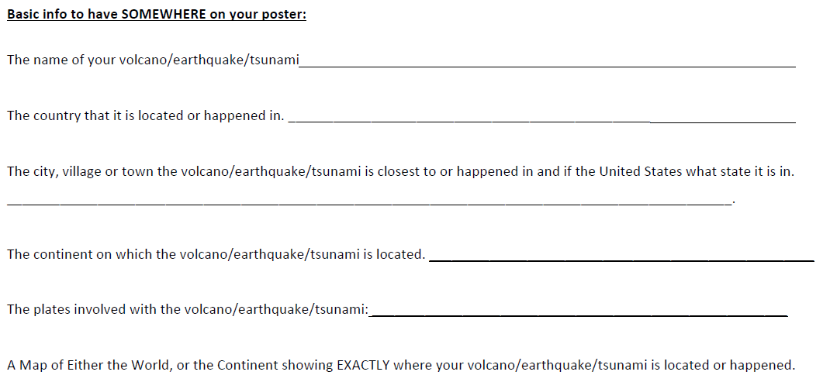
You may draw the map or print one.

You may use diagrams that may help answer more than one question.

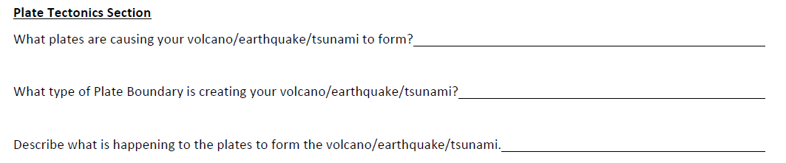

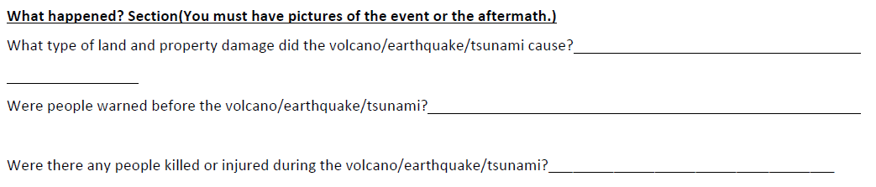

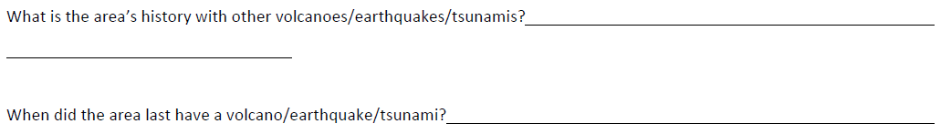

List 3 websites that you used. GOOGLE is not a website, it is a search engine!

Website #1 ____________________________________________
URL Link ____________________________________________________________

Website #2 ____________________________________________
URL Link ____________________________________________________________

Website #3 ____________________________________________
URL Link ____________________________________________________________

