EXCEL How-to
- Open up excel and type data in. It DOES matter what column you put your data into. The variable to go on the x-axis should be written first.
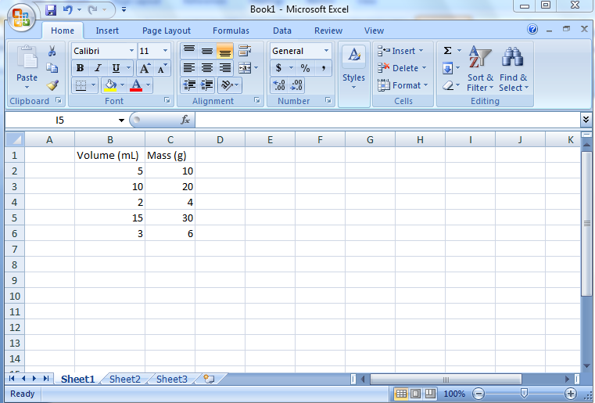
- To create your graph, highlight your data.
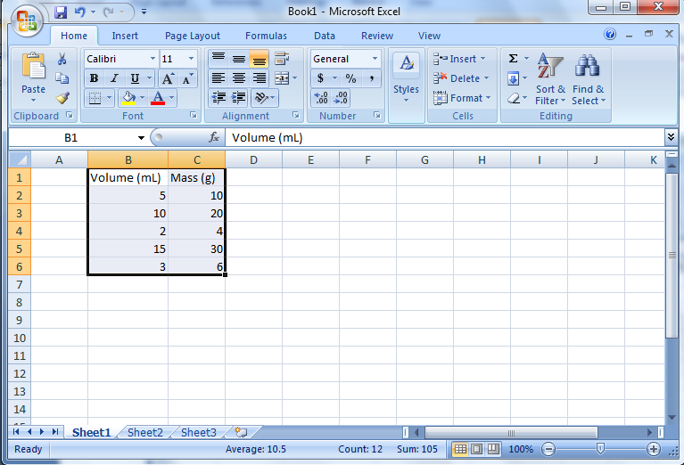

- Go up to the toolbar and click on insert. You then need to click on Scatter and choose the option in the upper left hand corner.
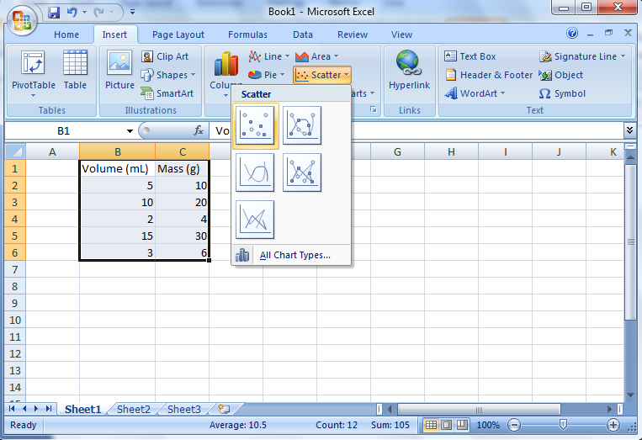
- That will give you your basic graph. You need to change/add a title to the graph however. To do this, left click twice on the words in the title and erase what is given. You then need to enter the title in the following format: "The Effect of (your independent variable) on (your dependent variable). This is the format you should ALWAYS use to title your graphs.
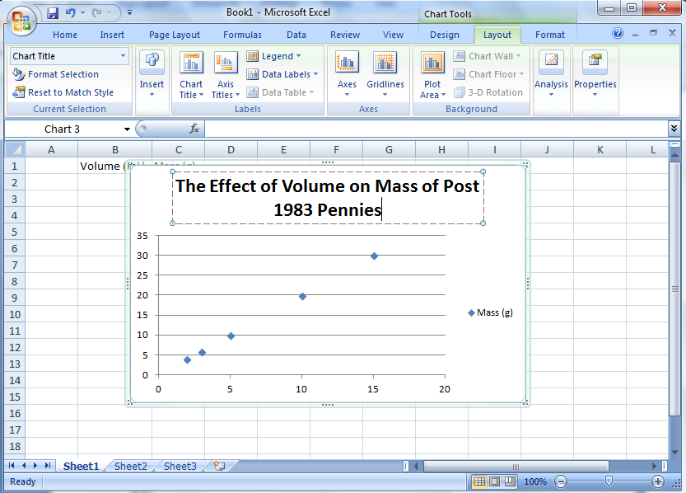

- You next need to label your axes. Click on your graph and a green plus sign will appear. You then need to click on the green plus sign to the right of your graph.
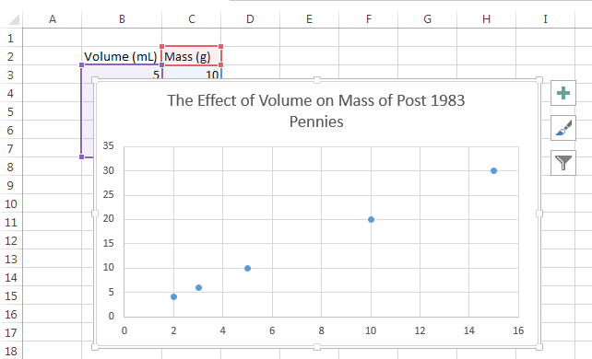
- You will then need to click on the Axis Titles box. This will allow you to click on the axes titles and change them. Remember, DRY MIX (dependant goes on the y axis and independent goes on the x)
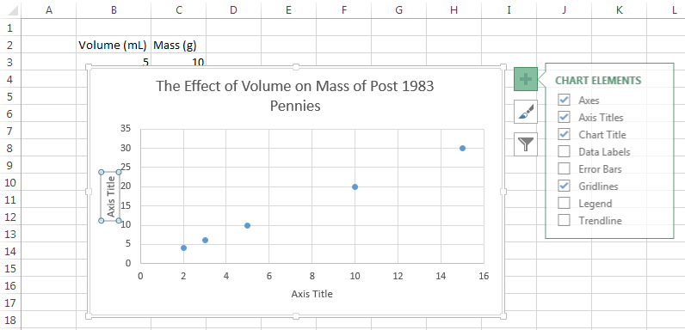

- We now need to add a trendline to this graph. To do this click on “Add Chart Element” found on the left of the screen. You will then need to click on the trend line option. From there, select the trend line you wish to add.
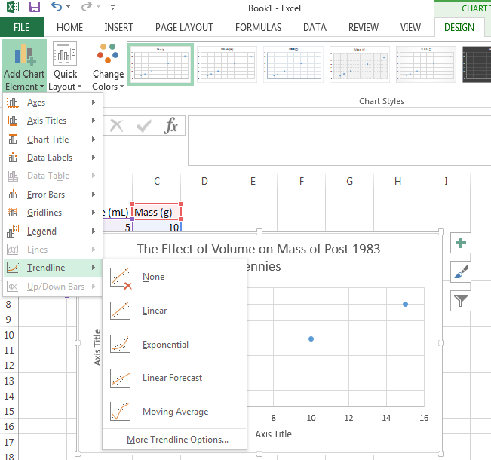

- To display the equation of the line, click on trend line. A “Format Trendline” window should pop up to the right of your screen. If you scroll to the bottom of those, you will find a “Display Equation on chart.” Click on that box.
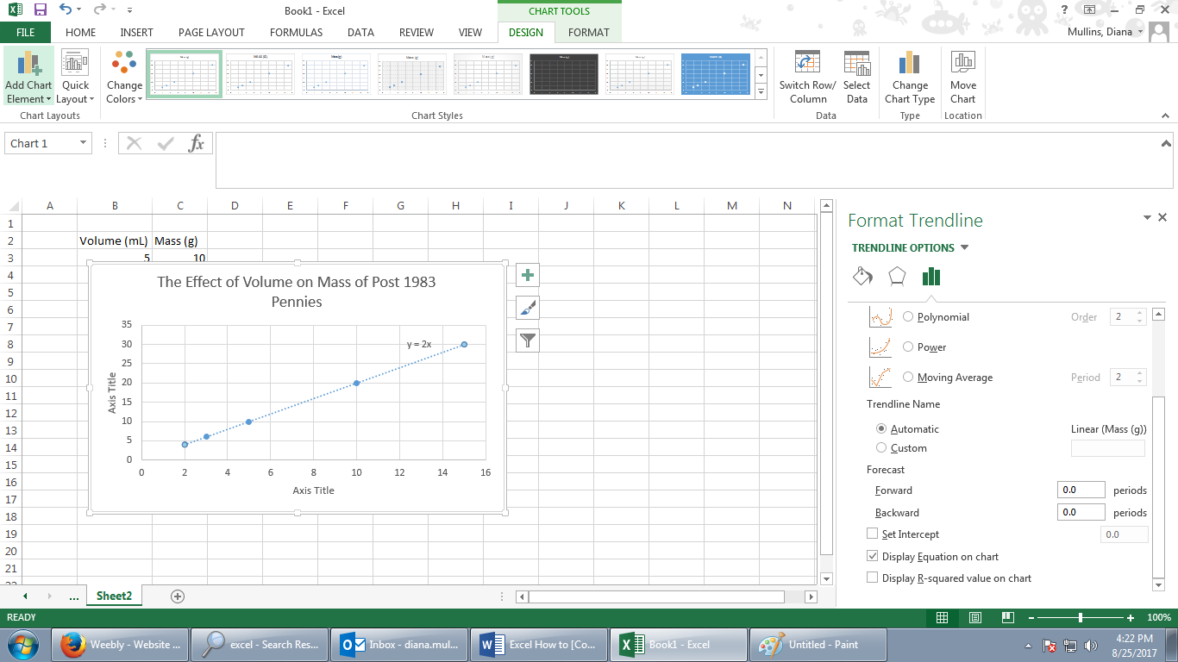

- Your final graph should look like this. To put this in to Microsoft Word, just right click on your graph, click copy, open up your word, and click paste where you want your graph to go.

