EXCEL How-to
Acceleration and Force Lab
- Open up excel and type data in. It DOES matter what column you put your data into. The variable to go on the x-axis should be written first. (NOTE: This is MADE UP DATA, NOT REAL DATA!!)
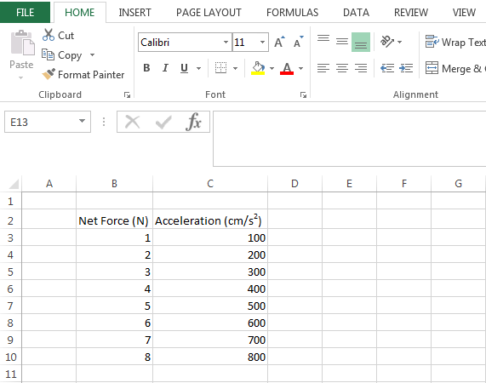
- To create your graph, highlight your data.
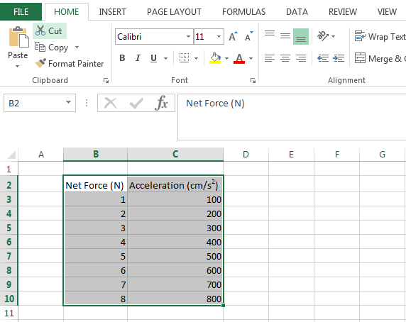

- Go up to the toolbar and click on Insert. You then need to click on Scatter and choose the option in the upper left hand corner.
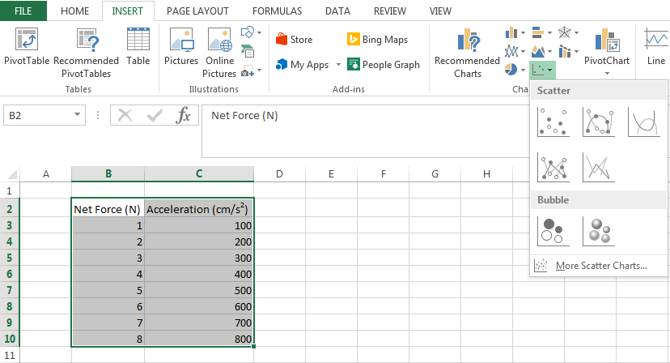
- That will give you your basic graph.
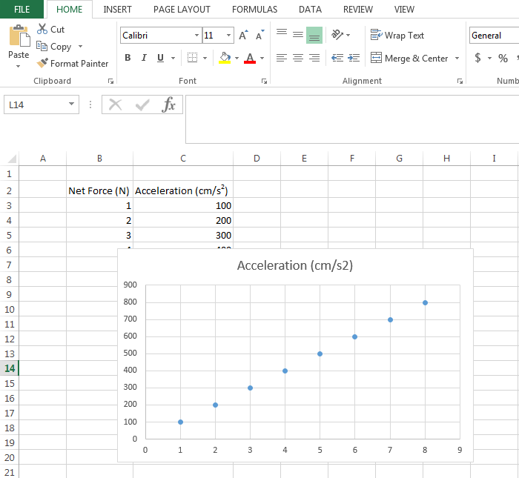

- You need to change the title of the graph however. To do this, left click twice on the words in the title and erase what is given. You then need to enter the title I have given you below.
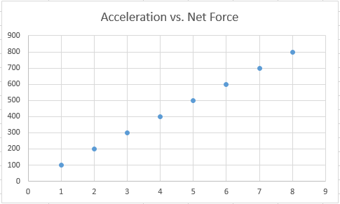

- You next need to label your axes. Click on your graph and a green plus sign should show up. When you click on that, a Chart Elements tab should open and you will need to click on Axis Titles. This will make your axis look like mine below. Double click on the Y axis and label it “Acceleration (cm/s²)”. Double click on the X axis and label it “Net Force (Newtons)”.

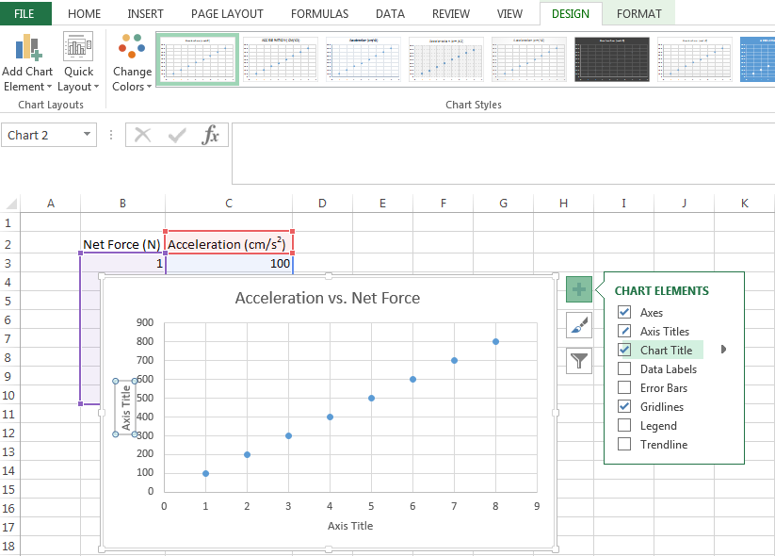

- We now need to add a trendline to this graph. To do this click on the green plus sign again and then check the Trendline box. This will automatically add a trendline for you.
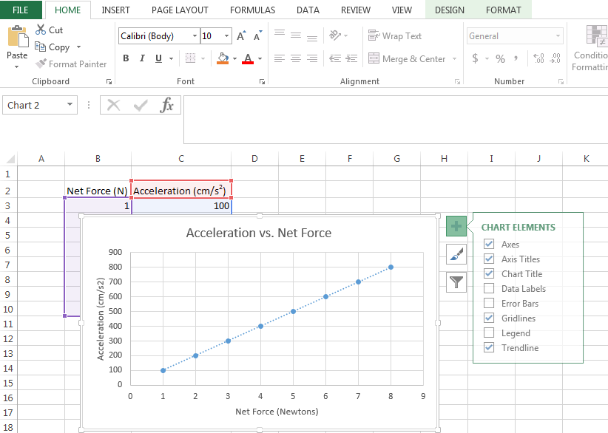

- Your final graph should look like this. To put this in to Microsoft Word, just right click on your graph, click copy, open up your word, and click paste where you want your graph to go.
