FREE-BODY DIAGRAMS (aka FORCE DIAGRAMS) are drawings used to show the relative size and direction of all forces acting upon an object in a given situation

NET FORCE on an object is the combination of all the forces acting on it. Don’t forget to include the direction.
BALANCED forces don't cause any change in the motion of an object. Balanced forces are equal and in opposite directions.
UNBALANCED forces cause the object to move. An object that is not already moving will begin to move in the direction of the larger force. An object that is already moving will change its speed and/or its direction.

Determine the net force in the free-body diagrams (FBD) below:
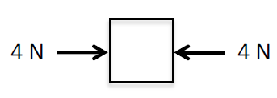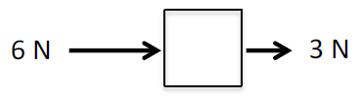

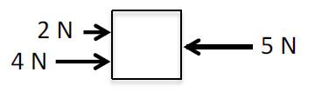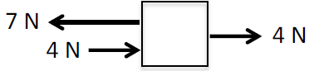

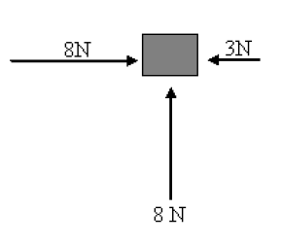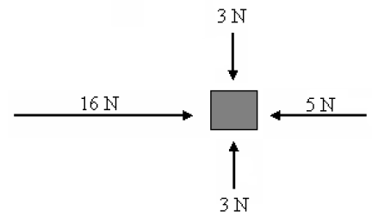
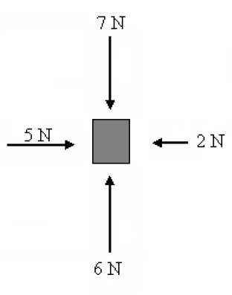

Now you will draw the free-body diagrams (FBD)!
Identify all the forces acting directly on the object. Vectors (arrows) will represent each force.
Here are 2 examples complete with the labels that you will use at times.
Each vector MUST have a label!
Tommy is pushing a box to the right. He’s making the box speed up.
Barb is not moving.

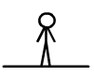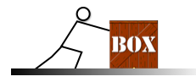

Coach Lankster and his wife were moving their new couch. Coach Lankster pulls to the right with a force of 30 N while Mrs. Lankster pushes to the right with a force of 25 N. The frictional force is 10 N.

Draw the FBD for the couch.
What is the net force of the couch?

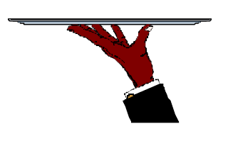  Waiter is holding up a tray while talking to a customer. | Draw the FBD for the tray.
An egg is free-falling from a nest in a tree.
Neglect air resistance.

