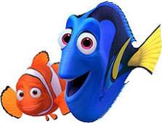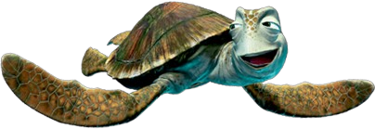“Finding Nemo” Marine Taxonomy

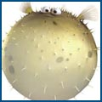

1. Name the phylum and class that Marlin and Coral (the clownfish) are classified under.
   1. **Phylum**: _______________
   2. **Class**: _________________
2. What type of organism do Marlin and Coral live within? ________________________
   1. This animal belongs to this **phylum**: _______________________
   2. Another example of an **organism from this phylum** would be: ____________________
   3. What are **stinging cells** called? ____________________

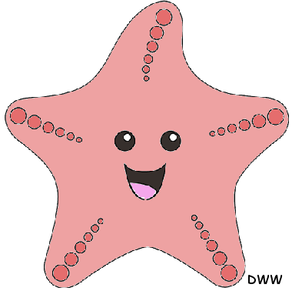

1. When Nemo is getting ready to go to school, what type of animal does he get stuck in? ______________
2. The school teacher is what type of fish? ______________________________
   1. **Phylum**: _____________________
   2. **Class**: _______________________
3. 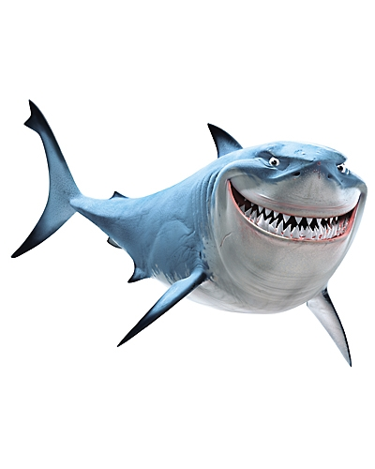The pink animal that ‘inks’ itself is what kind of animal? ______________________________
   1. 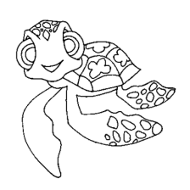**Phylum**: _____________________________
   2. **Class**: ______________________
4. Bruce, Anchor, and Chum are what type of animals? __________________________________
   1. **Phylum**: _______________________________________
   2. **Class**: _______________________________________
5. What kind of animals is Marlin’s joke about? _______________ and __________________
   1. 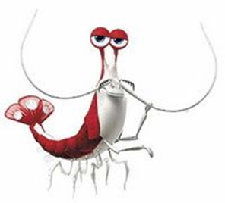**Phylum** of #1: ______________________
   2. **Phylum** of #2: ______________________
   3. What does H20 Intolerant mean? **_______________________**
6. During the fish tank scene, what kind of animal is:
   1. Peach: __________________ Belongs to **phylum**: ___________________
   2. Jacques: __________________ Belongs to **phylum**: ____________________
   3. Nigel: ____________________ Belongs to **phylum**: _____________________
   4. Darla: ____________________ Belongs to **phylum**: ______________________
7. What type of animal is swimming over the trench? ________________________
   1. **Phylum**: ____________________
   2. If Dory were human, what could she have done to stop the stinging of her wound? _______________________________________________________________

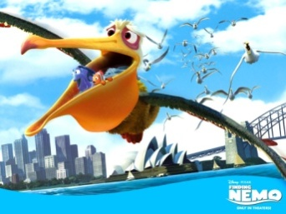

1. What **type** of animal is Crush? ____________________________
   1. **Phylum**: ________________________
   2. **Class**: __________________________
2. What kind of animal gives Marlin and Dory an unusual ride to Sydney? _______________
   1. **Class**: __________________
3. The seagulls and pelicans are in what **class**? _____________________________
4. What is the **Phylum** of organisms that can’t sting you (but look like jellies) called? (considered as not “true jellyfish”. ______________

14. Give an example of an animal from the film that display each type of **body symmetry**:

a. Asymetrical: ____________ b. Radial: _____________c. Bilateral: ___________

15. The barnacles attached to the whale that Marlin and Dory ride in belong in what **Phylum** of organisms? _______________ class? ________________

XC What is wrong with the whale (movement)? _______________________________________

16. [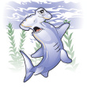](http://www.istockphoto.com/file_closeup/animals/marine_life/sharks/3357852_hammerhead_shark.php?id=335785)**Character Name Fish Species**

_____1. Anchor A. Clownfish

_____2. Baracuda B. Black Tip Reef Shark/Great White

_____3. Bloat C. Cleaner Shrimp

[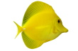](http://www.istockphoto.com/file_closeup/object/3869067_tropical_fish_zebrasoma_flavescens_on_white.php?id=386906)_____4. Bruce D. Bicolor Blenny/Royal Gamma Basslet

_____5. Bubbles E. Hammerhead

_____6. Chum F. Sea Horse

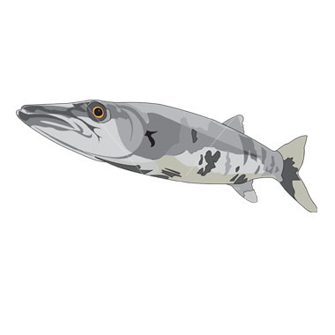_____7. Deb G. Gulf Flounder

_____8. Dory H. Black and White Humbug (4-Stripe Damselfish

_____9. Nigel I. Bat Ray

_____10. Gill J. Pink Seastar

_____11. Gurgle K. Great Baracuda

_____12. Jacques L. Moorish Idol fish

_____13. Mr. Johanson M. Yellow Tang

[](http://www.istockphoto.com/file_closeup/object/3671059_pelican_cartoon.php?id=367105)_____14. Mr. Ray N. Fine-spotted Porcupine fish/puffer fish

_____15. Nemo O. Green Sea Turtle

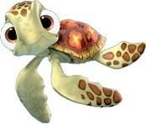_____16. Pearl P. Yellow Longnose Butterflyfish

_____17. Sheldon Q. Regal Blue Tang

_____18. Tad R. Common Pelican

_____19. Peach S. Mako Shark

_____20. Crush T. Flapjack Octopus

17. Why was Marlin able to withstand the jellyfish’s stinging? (hint: think about where he lives, and what that makes him adapted for) _________________

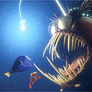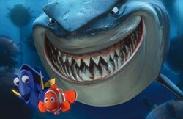

18. **Error**: When Mr. Ray sings his "Let's Name the Species" song, he isn't actually naming species. Porifera, Coelenterata, Ctenophora, Bryozoa, Arthropoda, Echinodermata, and Chordata are all _______________________. Hydrozoa, Scyphozoa, and Anthozoa are ________________ in the phylum ____________________, and Gastropoda is a class in the phylum _____________________. List the order of classification from largest to more specific: ______________ _____________ _______________ _____________ _______________ _____________ _____________

19. **Error:** The diving flag seen on the dentist's boat is the United States' "Diver Down" flag is what color(s)? _______________________________- This flag is not used in Australia, and would not be seen on the Great Barrier Reef. The Australian version is blue and white.

Remember the dentist guy? notice his name. it’s P. Shermann. And his name was constantly repeated in the movie, by Dory. Hmm.. P. Shermann… Peesherman… Feesherman.. Fisherman…he he he

20. The teacher brought the school to the “drop off”, what is this exactly ? ______________________

21. When Nemo is captured by the humans, Marlin swims after him. What sea floor feature does Marlin swim down to in order to get help? ____________________

22. The light of the angler fish acts as what device? *hint* Something that fishermen use to attract fish. ____________________

23. What on or in the fish produces this light and what is the lights’ scientific name? __________

24. Give at least 3 possible reasons that the water in the harbor looks so murky and dull.

______________________- _______________________- ___________________

