Enduring Science Skills Progress Analysis and Self Reflection
Our Class Goal
By the end of the school year, students will:
- Reach Proficiency
- Maintain Proficiency – OR
- Improve One Performance Level
according to the Enduring Science Skills Assessment.
Part I. Our Progress

Table 1: Scoring Guide
Performance Level | Score Ranges
Novice | 0-5
Apprentice | 6-10
Proficient | 11-15
Distinguished | 16-20

Table 2: Average Score (Out of 20) for All Classes
Classes | Fall | Winter | Spring
A1
A2
A3

Figure 1: Average Score (Out of 20) for All Classes

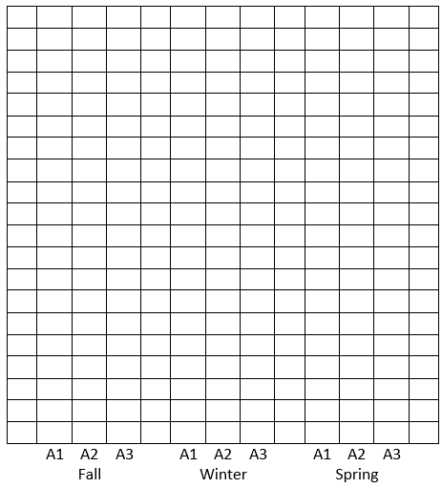

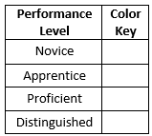

Part II. My Progress
Table 3: My Scores for the 2018 – 2019 School Year
 | Fall | Winter | Spring
My Scores
Figure 2: My Scores for the 2018 – 2019 School Year
 | Fall |  |  |  | Winter |  |  |  | Spring

Part 3. Fall Reflection
- How far away are you from proficiency (how many points)?

- Write a sentence describing your current ability to analyze data tables and graphs.

- Create an action plan to increase your ability to analyze graphs and date tables (what can YOU do)?

