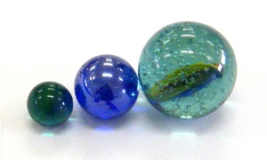

Don’t Lose Your Marbles

Questions
- What does momentum mean?
- What does conservation of momentum mean?
- Can we show that momentum is conserved in simple systems?

Introduction
This laboratory explores the concepts of momentum and conservation of momentum. Existing theory asserts that momentum is conserved. You will explore qualitatively the conservation of momentum.
In physics:
- Momentum is the mass (grams) multiplied by the velocity (cm/s). The letter P is used for momentum, m is used for mass, and v is used for velocity (speed).
P = mΔv
- Conservation means "stays the same." Usually this means, "the momentum after an event is the same as the momentum before an event." For this lab the "event" is a collision between marbles.

Equipment
- marbles
- rulers
- stopwatch (on your cell phone)
- wood block or other support
- tape

Part 1: Conservation of Marble Momentum: Rolling marbles
In part one we explore a simple system. Five marbles sit touching each other on the flat portion of a marble track. The marble track is made of two plastic rulers with grooves to guide the marbles. One or more marbles are released from an elevated end of the track.
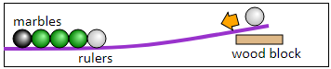

Procedure and Questions for Part One
- Create your ramp and track using the rulers and tape provided.
- Place 4 blue marbles and 1 red marble side by side halfway down your track. Release one red marble.
Q1. How many marbles are ejected ("kicked out") from the group?

- Release two marbles.
Q2. How many marbles are ejected from the group?

- Repeat for three, four, five... marbles.
Q3. How is the number in related to the number out?

- Release one marble from half-way up the ramp.
Q4. Is the inbound marble fast or slow?

Q5. Is the ejected marble fast or slow?

- Send a marble in at high speed.
Q6. Is the ejected marble fast or slow?

Q7. How is the speed (velocity) in related to the speed (velocity) out? (Are they the same or different?)

Q8. Design your own sketch/diagram showing marbles in = marbles out, speed in = speed out .

Part 2: Proving Law of Conservation of Momentum
You will now work in your group to try to verify conservation of momentum using the same setup you used for part 1, stopwatches, and mass balances. Fill in the blanks and data tables below and then answer the questions.
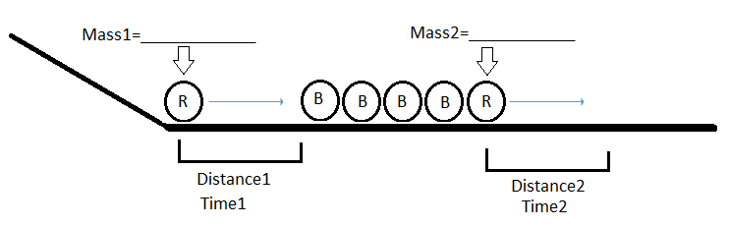

Trials | Distance1(cm) | Time1(s)
1
2
3

Trials | Distance2 (cm) | Time2(s)
1
2
3

Avg. Time1(s) | Velocity1  (cm/s) | Momentum1  (g*cm/s)

Avg. Time2(s) | Velocity2  (cm/s) | Momentum2  (g*cm/s)

Part 2 Analysis Questions
  - State the Law of Conservation of Mass. _______________________________________________________________________________________________________________________________________________________________________________________________________________

  - What was your calculated momentum before the collision?____________________

  - What was your calculated momentum after the collision?_____________________

  - Did your numbers prove the Law of Conservation of Momentum (yes or no)?_______

  - If no, what do you think happened? ________________________________________________________________________________________________________________________________

  - What could you have done to make your lab better? __________________________________________________________________________________________________________________________________________________________________________________________________________

