The Conservation of Momentum and Collisions Name:____________________

Data

Go to www.gigaphysics.com, then go to Virtual Labs, and then click Conservation of Momentum. (http://www.gigaphysics.com/momentum_lab.html)
Click New Experiment.
Part I: Measure the Carts
- Find the length of the purple cart, use your mouse to drag the cart over the caliper in the upper left corner of the lab.
- Find the masses of the carts by dragging each one in turn over the electronic balance in the upper right corner.
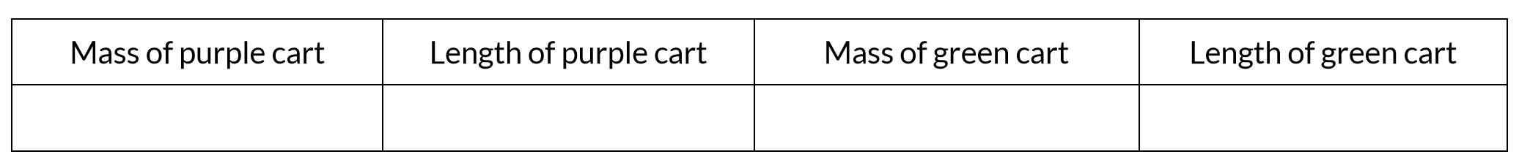
Part II: Inelastic Collisions
- Select “same direction” from the Carts’ Direction menu and “inelastic” from the Collision Behavior menu.
- Click “Start Carts” to put the carts in motion. The red numbers you will soon see tell you how many seconds it took each cart to pass through that photogate. If you lose track of which photogate is measuring which cart, notice the purple and green arrows labelling each; a half purple/half green arrow is used when both carts were stuck together as they passed through. You can also click Start Carts if you want to watch the collision again.
- Record your times in the data table. Also copy the lengths from part I. Be sure to add the lengths of the two carts when the carts are stuck together.
- Calculate each cart’s velocity and enter it in the table as well.
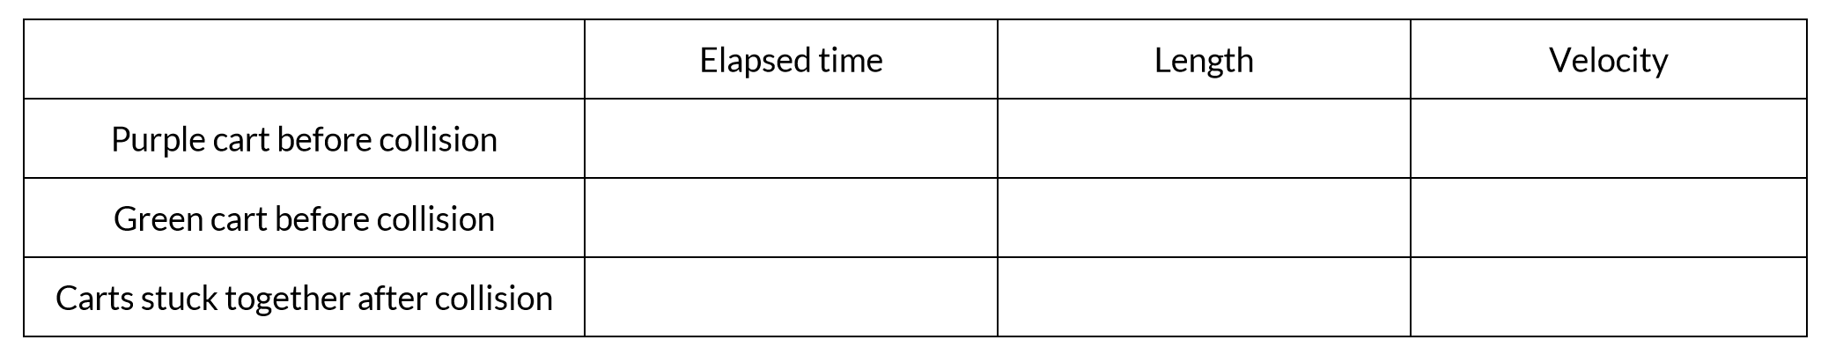
- Use the fact that momentum = mass$•$velocity to calculate the momentum of each cart. Remember to add the masses when the carts are stuck together.
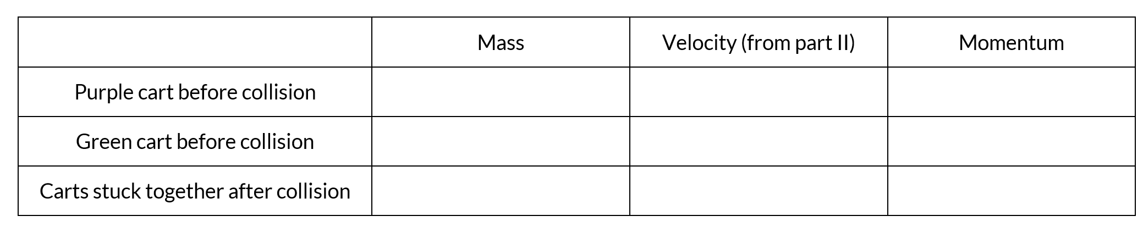
- Calculate the total momentum of the two carts before and after the collision.
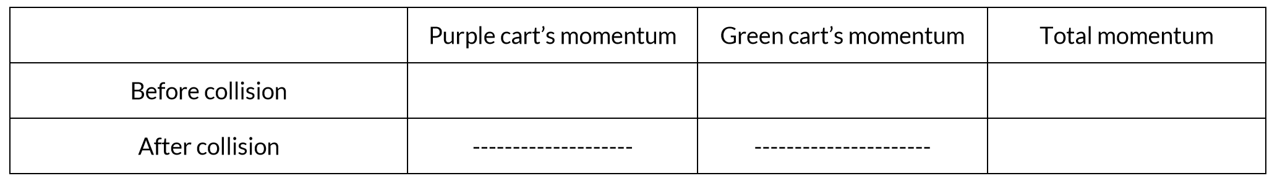

Part III: The Elastic Collision
- This time, set the Carts’ Direction to opposite and the Collision Behavior to elastic. Repeat the same steps as in part II. Remember, your lengths are the same from part I.
When you calculate the velocities and momentum, signs matter. Make sure that carts that are moving to the left have negative velocities. If you lose track of which direction the carts were going for each photogate, you have the arrows to help you, and you can click Start Carts to watch the collision again