Distance vs. Displacement

***EXTRA HELP: Foundations of Physical Science pg. 5***

1. Define **distance.**
2. Define **displacement.**
3. Provide two examples of the **units** used for distance.

|  |  |
| --- | --- |
|  | 1. **A truck travels one hundred meters East and then turns around and travels forty meters West.  What is the truck’s total distance and displacement?** |

|  |  |  |  |
| --- | --- | --- | --- |
|  |  | **A.** | distance =60 meters; displacement =140 meters East |
|  |  | **B.** | distance =140 meters; displacement =60 meters West |
|  |  | **C.** | distance =60 meters; displacement =140 meters West |
|  |  | **D.** | distance =140 meters; displacement =60 meters East |

Name:

***Below is Lenny’s path he takes every day from home to the playground. He loves his new Jordan’s and doesn’t want to scuff them so ONLY walks on the sidewalk. (1 sidewalk cube = 1m.)***

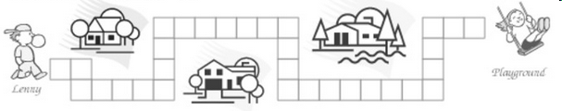

1. Calculate the total distance Lenny walks every day from his house to the playground.

6. Calculate the displacement between Lenny’s house and the playground.

Speed and Velocity

***EXTRA HELP: Foundations of Physical Science pgs. 13-15***

1. Explain the difference between speed and velocity.
2. Provide an example unit used for velocity.
3. What is the equation for velocity?

|  |  |
| --- | --- |
|  | 1. A dolphin swam 60 m in 3 seconds. What was the dolphin’s speed? |

|  |  |  |  |
| --- | --- | --- | --- |
|  |  | **A.** | 0.500 m/s |
|  |  | **B.** | 180 m/s |
|  |  | **C.** | 20 m/s |
|  |  | **D.** | 1800 m/s |

1. In the ticker tape below, a dot was made for a moving object every two seconds. Calculate the average speed of the object between A and B:

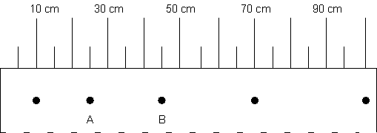

Name:

5. Calculate the speed of the object from the position vs. time graph shown below.

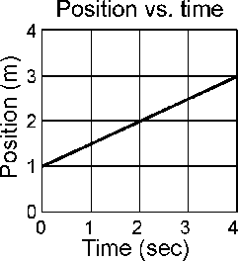

6. The Earth has a speed of 108,064.5 km/hr around the sun. The planet Mars has a speed of 86,868 km/hr around the sun. Which of the following graphs best represents the motion of the two planets?

|  |  |  |  |
| --- | --- | --- | --- |
| a. |  | c. |  |
| b. |  | d. |  |

Motion Maps

***EXTRA HELP: Foundations of Physical Science 13***

1. Provide examples of the units for time.
2. A stationary camera takes pictures of a falling ball at equal time intervals. Draw a motion map that represents the motion of the ball as it falls?
3. Explain the motion represented by each motion map below.

|  |  |
| --- | --- |
| a. |  |
| b. |  |
| c. |  |
| d. |  |

Name:

1. Calculate the average speed between 5m and 11m. The time between every dot is 2 seconds.

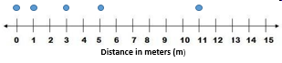

a. 15m/s c. 10m/s

b. 3m/s d. 11m/s

Match the correct motion map to the correct position vs. time graph.

|  |  |
| --- | --- |
| a. |  |
| b. |  |
| c. |  |
| d. |  |

1. 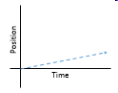 6. 6. 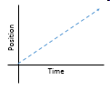

77.7. 7.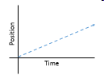 8.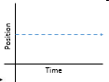

Acceleration

***EXTRA HELP: Foundations of Physical Science 33-36***

1. What is acceleration?
2. What is the equation for acceleration?
3. Provide 2 examples of the units used for acceleration.
4. A runner starts from rest and accelerates uniformly to a speed of 8.0 meters per second in 4.0 seconds. The magnitude of the acceleration of the runner is

Name:

1. In the following graph, the speed of a small object as it moves along a horizontal straight line is plotted against time. Calculate the magnitude of the acceleration of the object during the first 3 seconds

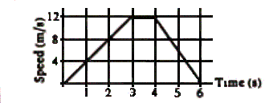

1. A car increases its speed from 10 meters per second to 12 meters per second in 4.0 seconds. Calculate for the average acceleration of the car during this 4.0-second interval.

Graphing and Graphs

***EXTRA HELP: Foundations of Physical Science 26-27, 29-32***

1. What is the independent variable in an experiment? Which axis does it go on when graphing?
2. What is the dependent variable in an experiment? Which axis does it go on when graphing?
3. The slope of a position vs. time graph is equal to:
4. The graph below represents the motion of an object. According to the graph, as time increases, what can be said about the velocity of the object?

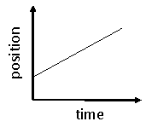

|  |  |
| --- | --- |
| a. | velocity increases |
| b. | velocity remains the same |
| c. | velocity decreases |
| d. | not enough information to say |

5. Which of the following *position* vs. *time* graphs represents the motion of something that moves forward, then reverses direction and moves backward?

|  |  |  |  |
| --- | --- | --- | --- |
| a. |  | c. |  |
| b. |  | d. |  |

Name:

1. Describe the motion between the following points:

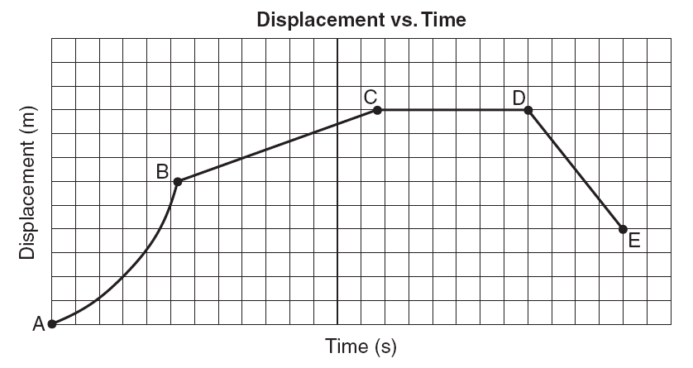

|  |  |
| --- | --- |
| Points | Motion Description |
| AB |  |
| BC |  |
| CD |  |
| DE |  |

|  |  |
| --- | --- |
| **6.** | **Use the graph below to answer the question to the right.**     1. **6.Which of the following statements best** 2. **represents a comparison of the two motions shown on the graph?** |

|  |  |  |
| --- | --- | --- |
|  | **A.** | the top line represents a greater acceleration |
|  | **B.** | the bottom line represents a greater acceleration |
|  | **C.** | the top line represents a greater velocity |
|  | **D.** | the bottom line represents a greater velocity |

**Forces**

***EXTRA HELP: Foundations of Physical Science 45, 49-51***

1. What is a force?
2. What is the equation for force?
3. What are the units for force?
4. What causes motion?

|  |  |
| --- | --- |
| **5.** | **In the picture below, a girl is sitting motionless on swing.  Her weight of 245 N is exerting a downward force on the swing.** |

|  |  |  |  |
| --- | --- | --- | --- |
| **What is the net force on the swing?** | | | |
|  |  | **A.** | 0 Newtons |
|  |  | **B.** | 245 Newtons upwards |
|  |  | **C.** | 490 Newtons upwards |
|  |  | **D.** | 490 Newtons downwards |

1. A person is pulled toward the Earth with a 500 N gravitational force. What is the force with which the Earth is pulled toward the person is:

Name:

1. 20N of force pushing to the east, 30N of force pushing west, which direction will the car go?
2. What is the mass of a puppy accelerating 2 m/s2 with a force of 12 Newtons?

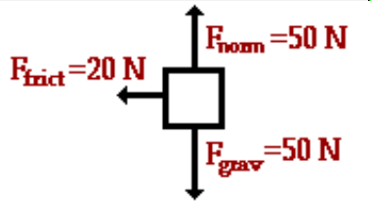

1. In which direction is this objecting accelerating?
2. Which of the following cases does the free body diagram below illustrate?

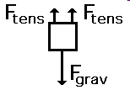

|  |  |
| --- | --- |
| a. | A book supported by two strings. |
| b. | A book supported by two springs |
| c. | A book lifted by two applied forces |
| d. | A book falling off a table |

1. Which of the following cases does the free body diagram below illustrate?

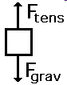

|  |  |
| --- | --- |
| a. | A back pack falling off a table |
| b. | A back pack being lifted off a table |
| c. | A back pack being placed on a table |
| d. | A back pack hanging over a student's shoulder |

Momentum

***EXTRA HELP: Foundations of Physical Science 60-61***

1. What is momentum?
2. The two carts shown below collide and stick together. Which direction would they move immediately after the collision and why?

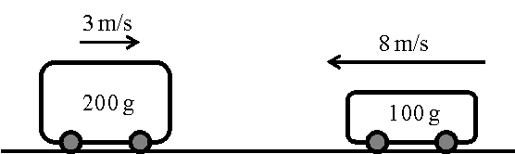

|  |  |
| --- | --- |
| a. | left; the cart moving that direction is faster |
| b. | right; the cart moving that direction has more inertia |
| c. | left; the cart moving that direction has more momentum |
| d. | neither, they will stop; the forces on the two carts must be equal |

1. In the diagram below, scaled vectors represent the momentum of each of two masses, *A* and *B*, sliding toward each other on a frictionless, horizontal surface.



Which scaled vector best represents the momentum of the system after the masses collide?

|  |  |  |  |
| --- | --- | --- | --- |
| a. |  | c. |  |
| b. |  | d. |  |

Name:

1. *On a smooth, level surface, a red marble of mass 0.02 kg moving at 2.0 m/s collides with a stationary yellow marble of equal mass. After the collision, the red marble stops completely, and the yellow marble moves in the direction the red marble was moving.*
2. **Calculate the momentum** of both marbles before the collision. Show your calculations and include units in your answer.
3. **Calculate the momentum** of both marbles after the collision. Show your calculations and include units in your answer.
4. If the red marble had more mass than the yellow marble, how would the momentum of the yellow marble change after the collision?

5. A rubber ball moving at a speed of 5 m/s hit a flat wall and returned to the thrower at 5 m/s. The magnitude of the momentum of the rubber ball

a. increased. c. remained the same.

b. decreased. d. was not conserved.

**Mass vs. Weight**

***EXTRA HELP: Foundations of Physical Science 47, 53***

1. What is the definition of mass?
2. Provide an example unit of mass.
3. What is the definition of weight?
4. Provide an example unit of weight.
5. A 50kg object with a weight of 490N is sent to the moon.
   1. What happens to the weight of the object?

* 1. What happens to the mass of the object?

Name:



|  |  |
| --- | --- |
|  | **Use the graphic below to answer question**  **The man in the above picture is pushing a box with a mass of 100 kg. When subjected to the gravitational acceleration of 9.8 m/s^2, what is the weight of this box?** |

|  |  |  |  |
| --- | --- | --- | --- |
|  |  | **A.** | 10.2 Newtons |
|  |  | **B.** | 9.8 Newtons |
|  |  | **C.** | 980 Newtons |
|  |  | **D.** | 10,200 Newtons |