Question: Is Earth made entirely of homogeneous, solid rock?
Name _________________________ Date ______________

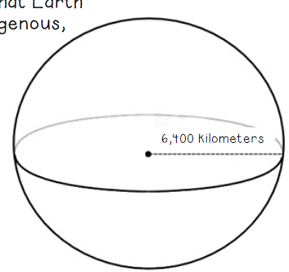
Background: Sometimes the simplest answer is the right one. Perhaps you, like other scientists, have wondered: What is inside our Earth? The simplest solution to that puzzle is that Earth is made entirely of the very same rock that we see at its surface. To test this theory, scientists study seismic waves, which travel through Earth, as a tool to discover what might be hiding beneath our feet. Earthquakes produce two types of seismic waves – Primary (P) waves and Secondary (S) waves. P waves and S waves behave differently as they travel through different materials. This can help scientists determine the characteristics of Earth’s interior.

Objectives: You will test this hypothesis by graphing real seismic data as it moves through Earth to its very center. We know that seismic waves travel ~1 km/s through solid rock. If Earth is homogeneous -- or made entirely of solid rock -- seismic waves should travel at a consistent speed through Earth’s interior to its core. If we observe changes in the speed seismic waves travel through Earth’s interior, we know that Earth must NOT be made entirely of homogenous, solid rock.
Earth’s center is roughly 6,400 km from its surface.

Create a double line graph showing the relationship between P-wave speed/S-wave speed and depth within the Earth (see Data Tables). Then answer the questions on the back.
KEY
- P-wave
- S-wave

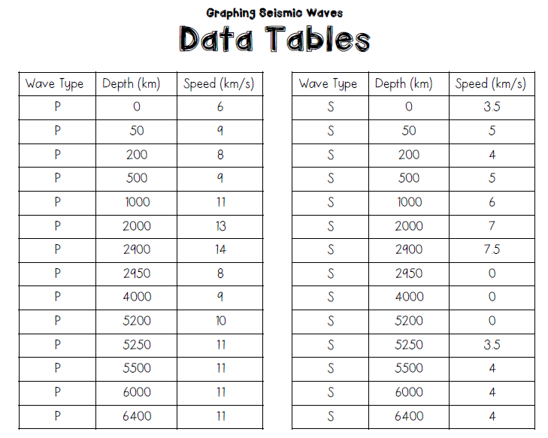

- Examine the graph you just made: “Changes in P-Wave and S-Wave Speed as Depth Increases”
What changes, patterns, or trends do you see?

- On your graph, draw two arrows that point to changes, patterns, or differences you see.
- What It Means: On your graph, for each of your captions, write a comment that explains what each change, pattern, or difference you see means.
What does it tell you about what’s happening?

- Using your graph, compare and contrast the data for P and S waves.

- P-waves are fast-moving longitudinal waves. They can travel through both solids and liquids. Their speed and direction changes when they encounter a medium of different density than the one they just passed through.

- Observe: At what three depths in Earth’s interior do P-waves abruptly change speed?

- Infer: What do these changes in speed suggest about the composition of Earth’s interior at these points?

- S-waves are slow-moving waves. They can travel only through solids.

- Observe: At what point do S-waves stop traveling through Earth’s interior?

- Infer: What does this suggest about the composition of Earth’s interior above 3,000 km?

- Infer: What does this suggest about the composition of Earth’s interior starting at 3,000 km?

