Cell Transport Virtual Labs and Review
Part 1. Osmosis
Visit http://www.glencoe.com/sites/common_assets/science/virtual_labs/LS03/LS03.html. Read the introduction on the left of your screen. You will then need to read and follow the procedures to complete the lab. Complete the simulation to fill out the table and answer the questions below.

Molecules Name | Red Blood Cell: Net Water Movement In/Out | Red Blood Cell: Appearance of Cell | Elodea: Net Water Movement In/Out | Elodea: Appearance of Cell | Paramecium: Net Water Movement In/Out | Paramecium: Appearance of Cell
Hypotonic Solution
Isotonic Solution
Hypertonic Solution

- Did water move into the cell or out of the cell while is was surrounded by the hypotonic solution?

- In which direction did the water move through the cell membrane when the cell was surrounded by the hypertonic solution?

- Compare and contrast what happens to an animal, a plant, and a Paramecium cell in a hypotonic, an isotonic, and hypertonic solution.

- Could Elodea or Paramecium from a freshwater lake be expected to survive if transplanted into the ocean? Explain.

- If you were to grill a steak, would it be better to put salt on it before or after you cooked it? Explain why, in terms of osmosis.

- Why does salad become soggy and wilted when the dressing has been on it for a while? Explain why, in terms of osmosis.

- An effective was to kill weeds is to pour salt water on the ground around the plants. Explain why the weeds dies, using principles discovered in this virtual lab.

Part 2. Cell Homeostasis Virtual Lab
Visit the link and follow the onscreen instructions to complete the lab. Make sure to answer the questions below. https://video.esc4.net/video/assets/Science/Biology/Gateway%20Resources/cell%20homeostasis%20virtual%20lab%20-%20activity/index.html

 | Beaker A | Beaker B | Beaker C | Beaker D | Beaker E
Beaker Sketch with Labels

 | A | B | C | D | E
Dialysis Tube with Labels (%)
Mass Before
Mass After 24 hours

Difference in initial and final masses

- Create a graph depicting the behavior of water in different concentrations of sugar solution.

- Which dialysis tubes had little or no change in mass after the 24-hour period?

- Why was pure water used as the control group?

- Why didn’t the mass of dialysis tubes “A” and “C” change over the 24-hour time frame?

- Which statement best describes how a cell responds to its external environment?

Cell Transport Review
- Complete the table by checking the correct column for each statement:
Statement | Isotonic Solution | Hypotonic Solution | Hypertonic Solution
Causes a cell to swell
Doesn’t change the shape of a cell
Causes osmosis
Causes a cell to shrink

Match the term with its correct description:
- Energy | e. active transport
- Facilitated diffusion | f. exocytosis
- Endocytosis | g. carrier protein
- Passive transport | h. channel protein

- ______ Transport protein that provides a tube-like opening in the plasma membrane through which particles can diffuse

- ______ Is used during active transport but not passive transport

- ______ Process by which a cell takes in material by forming a vacuole around it

- ______ Particle movement from an area of higher concentration to an area of lowed concentration

- ______ Process by which a cell expels wastes from a vacuole

- ______ A form of passive transport that uses transport proteins

- ______ Particle movement from an area of lower concentration to an area of higher concentration

- ______ Transport protein that changes shape when a particle binds with it

Match the term with its correct description:
- Transport protein | d. passive transport | g. exocytosis
- Active transport | - Osmosis | h. equilibrium
- diffusion | - Endocytosis

- ______The diffusion of water through a cell membrane.

- ______ The movement of substances through the cell membrane without the use of cellular energy.

- ______ Used to help substances enter or exit the cell membrane

- ______ When energy is required to move materials through a cell membrane

- ______ When the molecules of one substance are spread evenly throughout another substance to become balanced

- ______ A vacuole membrane fuses (become a part of) the cell membrane and he contents are released

- ______ The cell membrane forms around another substance, for example, how the amoeba gets its food

- ______ When molecules move from areas of high concentration to areas of low concentration

- Draw arrows showing the direction of transport then label the diagrams of cells using the following terms: diffusion, active transport, osmosis, facilitated diffusion, or equilibrium. You may use the terms more than once!

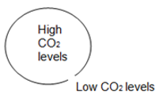 | 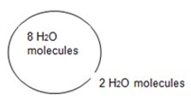 | 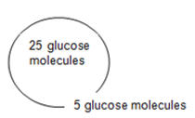
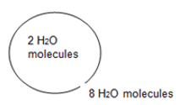 | 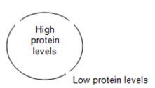 | 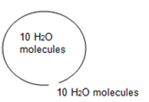

Use the diagrams to answer the questions. Draw arrows to indicate the movement of water.

a. Water will flow _____________________ (into the cell, out of the cell, in both directions).

b. The cell will ______________________ (shrink, burst, stay the same).

95% NaCl
5% H₂O
5% NaCl
95% H₂O

a. Water will flow _____________________ (into the cell, out of the cell, in both directions).

b. The cell will ______________________ (shrink, burst, stay the same).

5% NaCl
95% H₂O
5% NaCl
95% H₂O

a. Water will flow _____________________ (into the cell, out of the cell, in both directions).

b. The cell will ______________________ (shrink, burst, stay the same).

5% NaCl
95% H₂O
95% NaCl
5% H₂O

22. At which solution of concentration gradient is each cell diagram? (Hypotonic, Hypertonic, Isotonic)
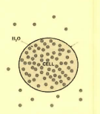 | 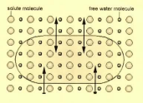 | 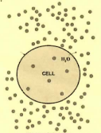

23. This diagram is moving from a high to a low concentration:_________________________________________
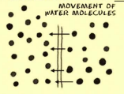
24. The process of using a transport protein to move particles across the membrane:
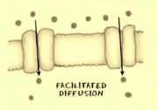

- Describe the processes occurring in the following pictures:
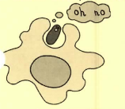 | 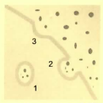 | 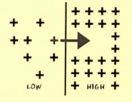
a. | b. | c.

