Introduction to the Electromagnetic Spectrum
Name:
Procedure:
Use the information below to:
- Fill in the numbered blanks on the Wavestown picture with the correct wave type
- Circle and label examples of the different wave types found in the picture of Wavestown

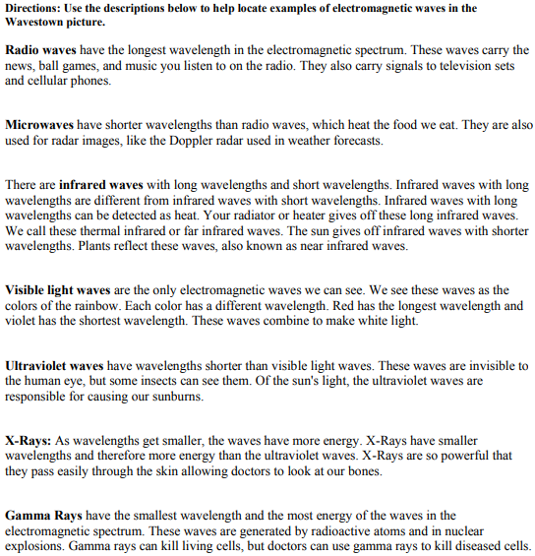

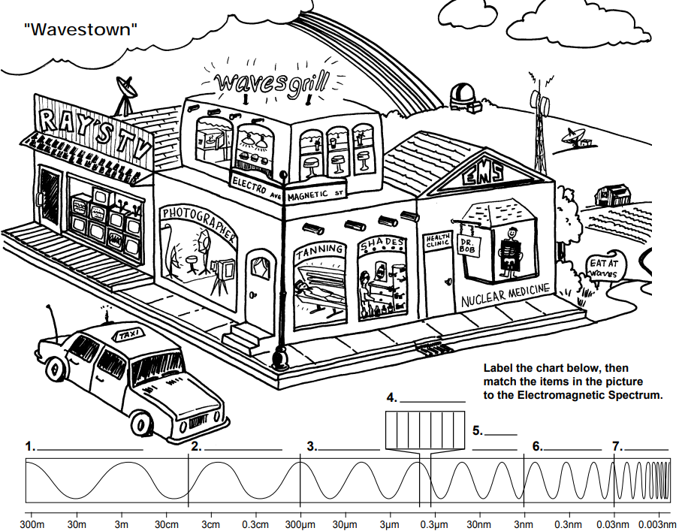
Use the information from the front page and watch the video below to fill out diagrams below. The video can also be found on my website!
https://imagine.gsfc.nasa.gov/science/toolbox/emspectrum2.html
1.
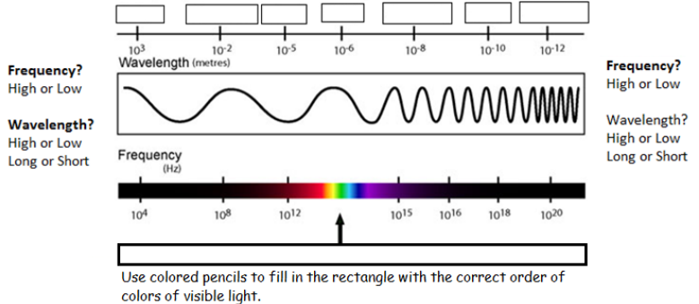
2.
3.
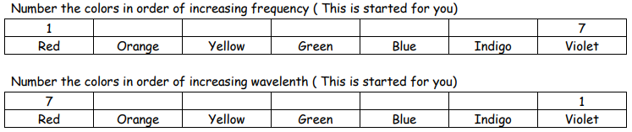
4. Conduct an internet search to answer the following questions:
