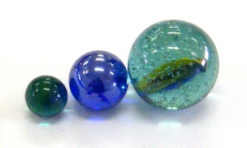

Losing your marbles

Questions
- What does momentum mean?
- What does conservation of momentum mean?
- Can we show that momentum is conserved in simple systems?

Introduction
This laboratory explores the concepts of momentum and conservation of momentum. Existing theory asserts that momentum is conserved. You will explore qualitatively the conservation of momentum.
In physics:
- Momentum is the mass (grams) multiplied by the velocity (cm/s). The letter P is used for momemtum, m is used for mass, and v is used for velocity (speed).
P = mΔv
- Conservation means "stays the same." Usually this means, "the momentum after an event is the same as the momentum before an event." For this lab the "event" is a collision between marbles.

Equipment
- marbles
- rulers
- stopwatch (on your cell phone)
- wood block or other support
- tape

Part 1: Conservation of Marble Momentum: Rolling marbles
In part one we explore a simple system. Five marbles sit touching each other on the flat portion of a marble track. The marble track is made of two plastic rulers with grooves to guide the marbles. One or more marbles are released from an elevated end of the track.
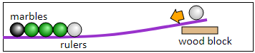
All questions for part 1 AND the Sketch/Drawing should be answered on your OWN sheet of paper!

Procedure for part one
- Release one marble. How many marbles are ejected ("kicked out") from the group?
- Release two marbles. How many marbles are ejected from the group?
- Repeat for three, four, five... marbles.
- How is the number in related to the number out?
- Release one marble from half-way up the ramp. Is the inbound marble fast or slow? Is the ejected marble fast or slow?
- Send a marble in at high speed. Is the ejected marble fast or slow?
- How is the speed (velocity) in related to the speed (velocity) out?
As you work on the above questions, experiment. Play with the marbles. How do the marbles know what to do? How does a marble know whether to go or to stay? How do the marbles count? Just how smart is a marble? Play gently – marbles can and do break – but do play.

Sketch or drawing

Design your own. You decide how to best present marbles in = marbles out, speed in = speed out in a drawing or sketch.

Part 2: Proving Law of Conservation of Momentum
You will now work in your group to try to verify conservation of momentum (see part two) using the same setup you used for part 1, stopwatches, and mass balances. You will create a poster to share your findings. You poster will need to include the following information:
- Title
- Question
- Procedure
  - Step by step in paragraph format
- Variables
  - Constant, independent, dependent
- Data Table
  - Make sure to include your units!!
- Diagram
  - Show your setup with the marbles and what you did
- Conclusion
  - Explain your results and how they prove the Law of Conservation of Momentum

