Motion Map Reinforcement
Name:
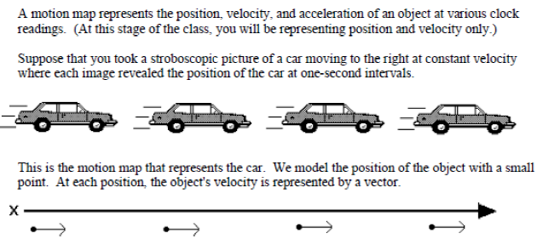
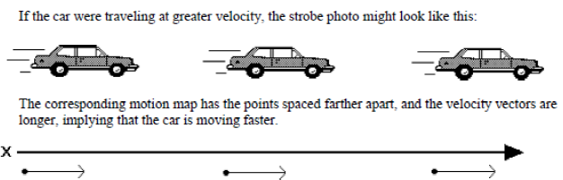
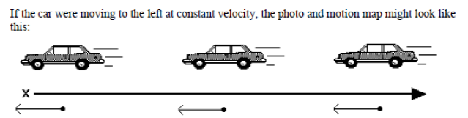
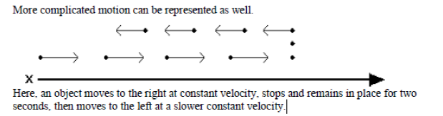

- Explain the motion for each of the trails in the space provided.

a.
b.
c.

d.

- Describe the motion represented by the motion map below.
