Bell Ringer 8/29/17
Motion Map Practice
Data Table  Distance (yd) Time (s)  10 2  20 4  30 6  40 8  50 10 | Visual Representation (Motion Map)  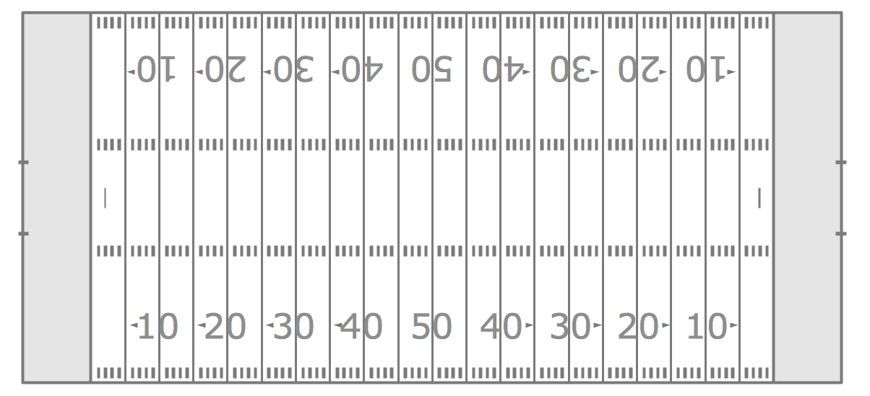
Graphical Representation

Written Description of Motion:

Bell Ringer 8/29/17
Motion Map Practice
Data Table  Distance (yd) Time (s)  10 2  20 4  30 6  40 8  50 10 | Visual Representation (Motion Map)
Graphical Representation

Written Description of Motion:

