Motion Map and Distance vs. Time Graph Practice Worksheet
Sketch a motion map and distance vs. time graph corresponding to the following descriptions of motion.
Scenario | Motion Map | Distance vs. time graph
1. The object is moving in the positive direction at a constant (steady) speed.
2. The object is standing still.
3. The object moves at a negative constant speed
4. The object starts at 5m and moves at a negative constant speed for 8 seconds, stops for 4 seconds, and then moves at a constant positive speed for 4 seconds
5. The object moves at a pos. constant speed stops for 6 seconds, stops for 2 seconds, then moves at a constant negative speed for 6 seconds

Write the correct graph letter in the corresponding scenario box below.
a.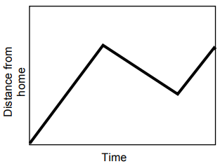 | b.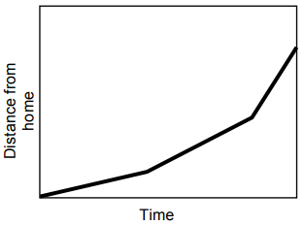 | c.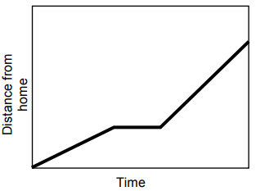
d.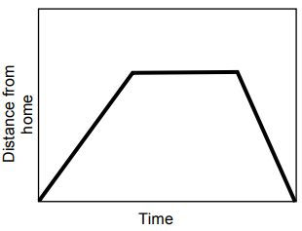 | e.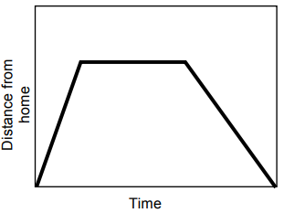

 | Scenario | Corresponding Graph
1. | Opposite Tom's home is a hill. Tom climbed slowly up the hill, walked across the top, and then ran quickly down the other side
2. | Tom walked to the store at the end of his street, bought a newspaper, and then ran all the way back.
3. | Tom ran from his home to the bus stop and waited. He realized that he had missed the bus so he walked home.
4. | Tom walked slowly along the road, stopped to look at his watch, realized he was late, and then started running.
5. | Make up your own story below!

