Station 1
Position vs. Time Graphing Practice
Directions: Graph both sets of data below on the same graph, then answer the questions below. Label each graph with the name of the runner.
C.J.’s Results:
100 m Outdoor Track

Time | Distance
s | m
.2 | 0
2.5 | 10
3.5 | 20
4.5 | 30
5.5 | 40
6.5 | 50
7.6 | 60
8.5 | 70
9.5 | 80
10.6 | 90
11.5 | 100

Donovan Bailey’s Results:
100 m Outdoor Track

Time | Distance
s | m
.1 | 0
1.8 | 10
2.8 | 20
3.7 | 30
4.6 | 40
5.5 | 50
6.3 | 60
7.1 | 70
8.0 | 80
8.9 | 90
9.8 | 100

Position vs. Time for CJ and Donovan
Station 2
Use your graph to find information to answer the following questions:
- Approximately how far had C.J. traveled after 1.0 second?

- Approximately how far had Donovan Bailey traveled after 1.0 second?

- Approximately how far had C.J. traveled after 5.0 seconds?

- Approximately how far had Donovan Bailey traveled after 5.0 seconds?

- Is one of the runners ahead of the other runner during the entire race? How do you know by reading the graph?

- Predict and justify what Donovan Bailey’s distance would be at 12s.

- Use the equation speed = distance/time to complete the following calculations. Note: you will need to use the change in distance (final distance – initial distance) and change in time (final time – initial time)
C.J.’s Speed | Donovan Bailey’s Speed
d_{f}= | d_{f}=
d_{i}= | d_{i}=
t_{f}= | t_{f}=
t_{i}= | t_{i}=
Show your work here! | Show your work here!

Station 3

Tracking Distance, Time, and Average Speed
Examine the distance and time data for the walker shown below:

0s 1s 2s 3s 4s 5s 6s 7s 8s 9s

0m 2m 4m 7m 9m 11m 14m 16m 17m 18m

- Describe the speed of the walker for the entire trip using words:

- What is the average speed of the walker for the first 4 seconds of the walk? Show your work below:

- What is the average speed of the walker from 2 seconds to 6 seconds? Show your work below:

- What is the average speed of the walker for the entire walk? Show your work below:

- Is the average speed greater from 3 seconds to 5 seconds or from 6 seconds to 9 seconds? Explain.

- Create a distance vs. time graph that 7. Bonus: Create a speed vs. time graph that
represents the motion of the entire walk: represents the motion of the entire walk:

Station 4
Sketch a motion map and distance vs. time graph corresponding to the following descriptions of motion. On the motion map, a dot is made every 2 seconds.
Scenario | Motion Map | Distance vs. time graph
1. The object is moving in the positive direction at a constant (steady) speed.
2. The object is standing still.
3. The object moves at a negative constant speed
4. The object starts at 5m and moves at a negative constant speed for 8 seconds, stops for 4 seconds, and then moves at a constant positive speed for 4 seconds
5. The object moves at a pos. constant speed stops for 6 seconds, stops for 2 seconds, then moves at a constant negative speed for 6 seconds

Station 5
Write the correct graph letter in the corresponding scenario box below.
a.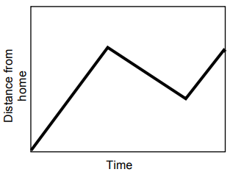 | b.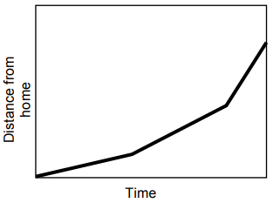 | c.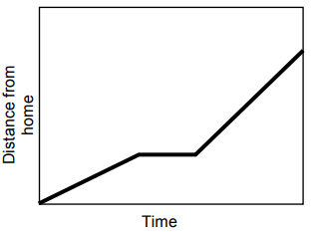
d.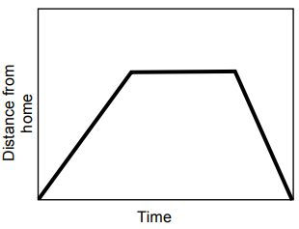 | e.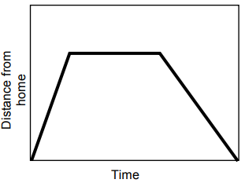

 | Scenario | Corresponding Graph
1. | Opposite Tom's home is a hill. Tom climbed slowly up the hill, walked across the top, and then ran quickly down the other side
2. | Tom walked to the store at the end of his street, bought a newspaper, and then ran all the way back.
3. | Tom ran from his home to the bus stop and waited. He realized that he had missed the bus so he walked home.
4. | Tom walked slowly along the road, stopped to look at his watch, realized he was late, and then started running.
5. | Make up your own story below!

Station 6
Race Car Brainstorming
In the next few class periods, we will begin designing the first of 3 cars you will be making during this unit. The first car you will be making is one that is made for speed. Your cars will be made out of paper with plastic wheels and wooden dowels that I will be providing. In the space below, begin brainstorming on what you would like your car to look like. The fastest car built will be the winner for round 1 (there are 3!!)
Create a sketch of your car here:

Write down any extra ideas down here:

