Orbital Speed and Saturn’s Moons & Rings
Objective: How do the speed of the rings and the moons of Saturn move differently? Does it depend on the mass of the orbiting object? Does it depend on the distance of the orbiting body (moon or ring particle) from the Saturn? Using the data and questions below you will find out.
Using the data table provided, complete a graph comparing orbital speed vs. distance from center of Saturn.
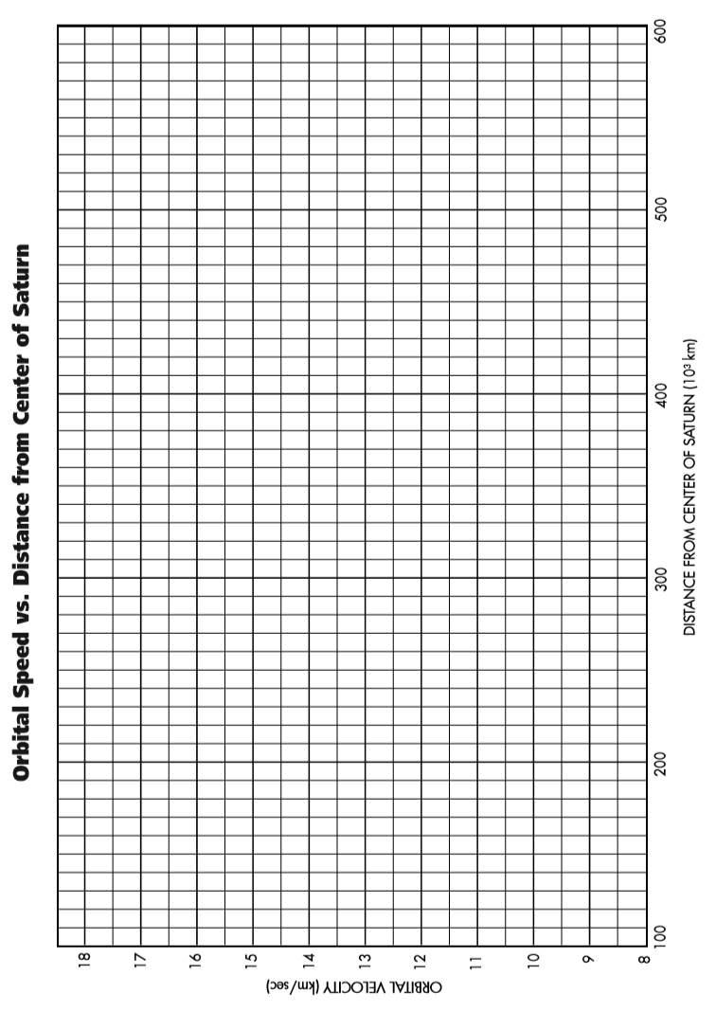
- Explain how orbital speed changes as you go farther from the center of Saturn. [look at the relationship of your graph]

Orbital Speed and the Solar System

- Write a description of the forces that keep the planets and asteroids of our Solar System in orbit about the Sun.

- Predict: Write down your predictions how the orbital speed of the planets in our Solar System changes with distance from the center of the Sun.

GRAPH: On a separate sheet of graph paper, graph the provided data: Orbital Speed for each planet and the Distance from the Sun for each planet

- Write a summary of your discoveries about orbital speed. How does orbital speed depend on distance from the sun to a planet? For a given distance from the center of the sun, does the orbital speed depend on mass or size?

