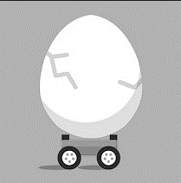
Paper Car Crash with Egg Research
Name:
Conduct research about car crashes and answer the following questions.
- What is impulse?

- What features on a car keep it safe in a collision?

- What features do you want to include on your car to keep an egg safe in our collision?

- Draw 3 different designs. Be specific in your design elements and explain your choices.
Design | Design | Design
Explanation | Explanation | Explanation

