Protein Structure and Function Practice

- Do you expect the secondary structures, alpha helices and beta sheets to hold their shape at high temperature? Why or why not?

- Describe 5 functions proteins may perform.

- What are the monomers of proteins? How many different kinds are there?

- What elements are found in proteins?

- 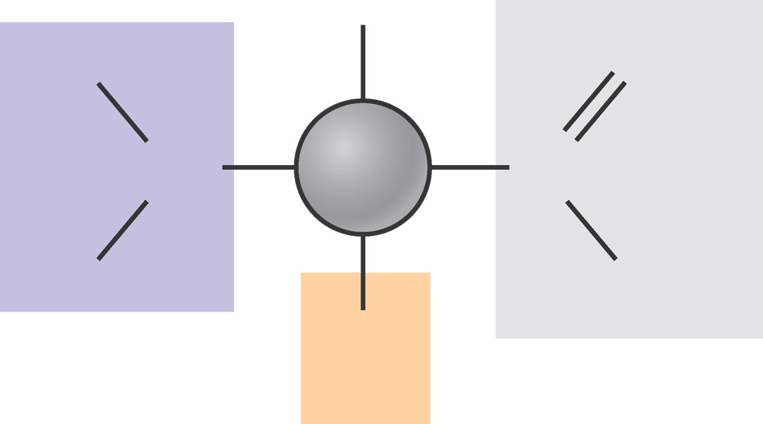Label the amino acid shown below.
H
H
N
H
C

C
O
OH

- Which part of an amino acid determines its specific properties?

- When 2 amino acids are joined together by dehydration synthesis a _______________________ bond is formed.

- What is a polypeptide?

- What makes different kinds of proteins unique?

- What is denaturation?

Different classes of amino acids
Amino acids can be grouped together based on the characteristics of their R groups. The different amino acids in each group are shown on the last page of this packet.

Non-polar amino acids are hydrophobic. “Hydrophobic” means fear of water. Hydrophobic, or non-polar, amino acids are those that do not like to be in contact with water because their R groups have no areas that are charged. These amino acids have no oxygen (O), nitrogen (N) or phosphate (P) in their R groups. Instead these amino acids have R groups primarily composed of carbon (C) and hydrogen (H) or ring structures.

- Look at the sheet of amino acids on the last page. Note three non-polar amino acids below.
  - ___________________________________
  - ___________________________________
  - ___________________________________

Polar amino acids are hydrophilic or water loving. These amino acids have OH or SH groups in their R groups. These OH or SH groups carry a partial charge, and are thus attracted to water.

- Look at the sheet of amino acids on the last page. Note three polar amino acids below.
  - ___________________________________
  - ___________________________________
  - ___________________________________

Charged amino acids have either a positive or negative charge in their R groups.

Look at the sheet of amino acids on the last page. Note three charged amino acids below. Following each amino acid listed, note whether it has a positive or negative charge.

  - ___________________________________
  - ___________________________________
  - ___________________________________

Protein folding and 3-dimensional shape (“Rules” of Protein Bending)
Proteins are composed of long chains of amino acids. The order in which these different amino acids appear will determine the 3 dimensional shape of the protein. Interactions between the different R groups will cause the protein to assume and maintain a specific structure. When proteins fold, different amino acids that are distant from each other in the long chain of amino acids may be near each other.

Because the human body is composed primarily of water, most proteins in the human body are dissolved in water. Thus, when proteins fold, they will assume a structure such that the side chains of most hydrophobic amino acids are on the inside of the molecule near each other. This is because they want to avoid water.

Polar amino acids will like to be near water and thus will be found on the portions of the protein in contact with water.

Positively charged side groups will repel one another. Instead the positively charged side groups will be attracted to negatively charged side groups. The attractive force between positive and negative charges are some of the forces which help a protein maintain its structure.

- What does the word hydrophobic mean?

- Explain how a hydrophobic amino acid will behave. How will this affect the shape of a protein?

- What does the word hydrophilic mean?

- Explain how a hydrophilic amino acid will behave. How will this affect the shape of a protein?

- How do charged amino acids affect the structure of a protein?

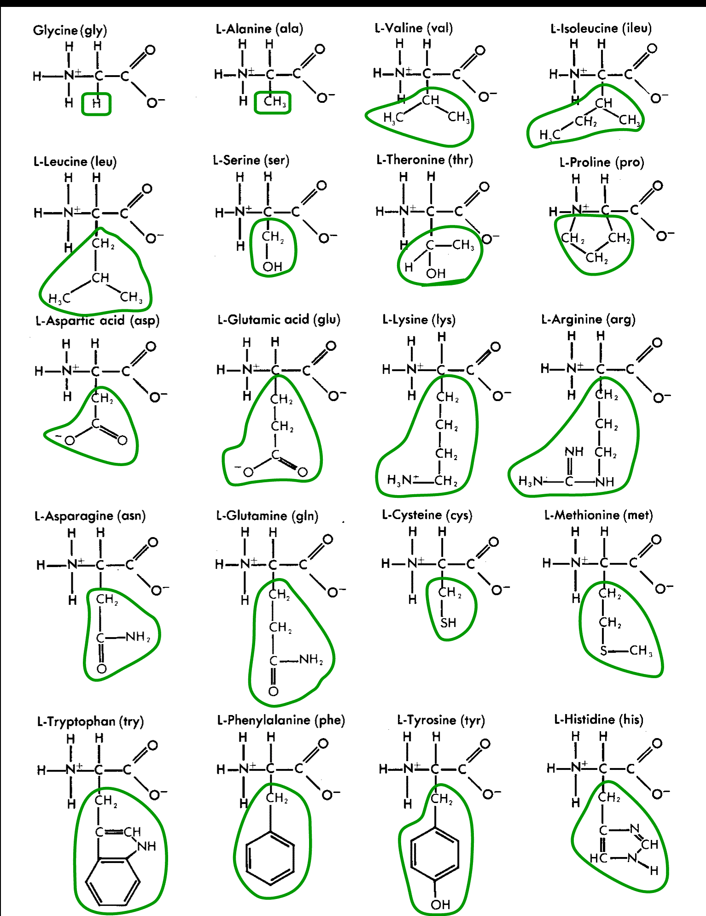
Paper Protein Analysis
- During which step was the Primary Structure created?

- During which steps were the Secondary Structures created?

- During which step was the Tertiary structure finally created?

- Determine if each of the amino acids used are charged, hydrophobic, or hydrophilic.
Amino Acid | Charge, Hydrophobic, or Hydrophilic
Arginine
Histidine
Proline
Isoleucine
Lysine
Methionine
Alanine
Valine
Leucine
Glycine

- Did your model follow the “rules” of protein bending? Why or why not?

