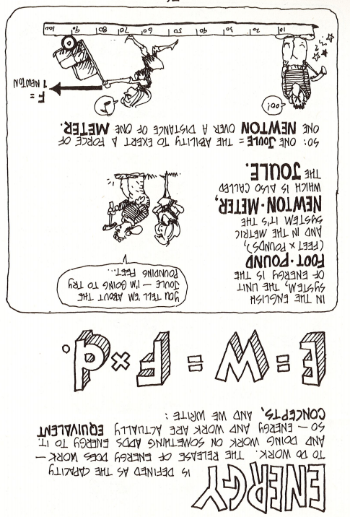

1. What is energy?
2. Put into your words what E = W = F x d means.
3. What is the unit for energy we will be using?
4. One Joule is equal to one ______________________________ -_______________________________.

**Directions: Use the notes on the left side to answer the questions on the right. Use this information to then answer the worksheet questions at the end.**

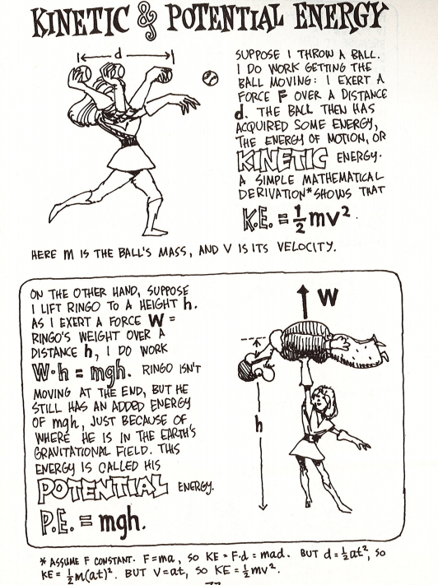

1. Explain what Kinetic Energy is.
2. Write the equation for Kinetic Energy.
3. What is the ONLY variable in the equation that will get squared?
4. What is potential energy?
5. What is the equation for potential energy?
6. Potential energy is dependent upon what?

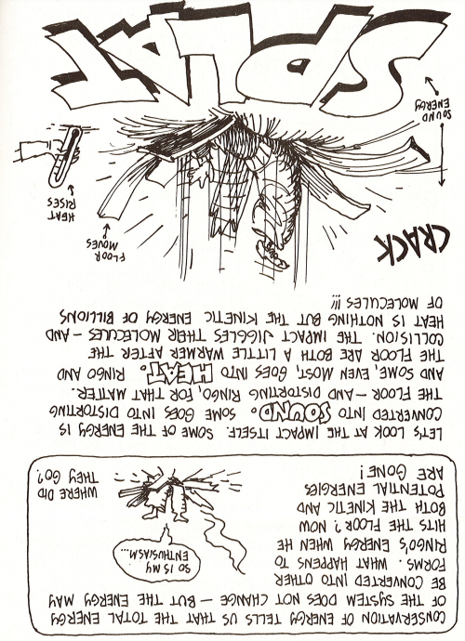

1. Explain what conservation of energy is.
2. To what forms in energy usually “lost” (not really lost, but may not be the type of energy that is being focused on)?

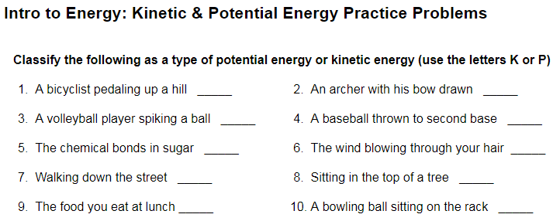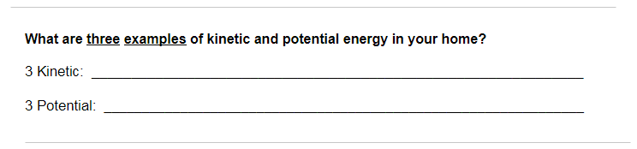

1. The velocity of a car is 65 m/s and its mass is 2515 kg.  What is its Ek (Kinetic Energy)?

M =

V =

Ek =

1. If a 30 kg child were running at a rate of 9.9 m/s, what is his Ek?

M =

V =

Ek =

1. A brick is suspended above the ground at a height of 6.6 m.  It has a mass of 5.3 kg. What is the Eg (Potential Energy)of the brick?

M =

H =

Eg =

1. A boy stands on a high-dive that is 4.8 m tall.  If the boy has a mass of 66 kg, what is his Eg?

M =

H =

Eg =

1. A sky diver is preparing to jump out of a plane that is flying at a height of 2200 m.  If the sky diver has a mass of 78 kg, what is her Eg?

M =

H =

Eg =

1. Your 1500 kg car is being serviced and is on the elevated platform 5.3 m above your head. What is the gravitational potential energy of your car?

M =

H =

Eg =

1. A diver has 3400 J of gravitational potential energy after stepping up onto a platform that is 6.0 m above the water.  What is the diver's mass in kilograms?

M =

H =

Eg =

**Energy Conservation**

Apply the Law of Conservation of Energy to the situations below.  Provide the missing values in the figures. Ignore resistance/drag.

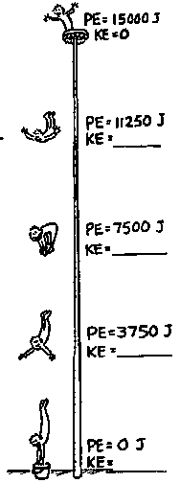

**SHOW‌ ‌ALL‌ ‌YOUR‌ ‌WORK!!‌ ‌**

 ‌

 ‌

 ‌

 ‌

 ‌

 ‌

 ‌

 

 

 

 

 

 

 

 

 

