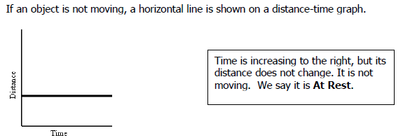
Position vs. Time Graph Reinforcement
Name:
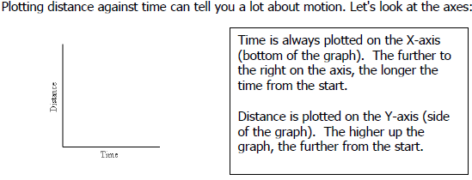
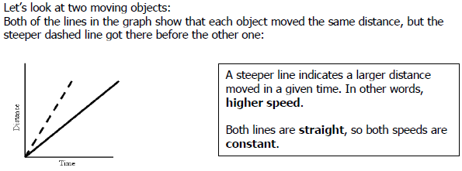
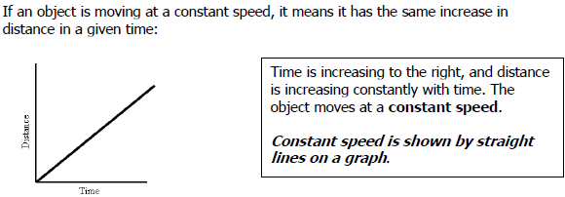

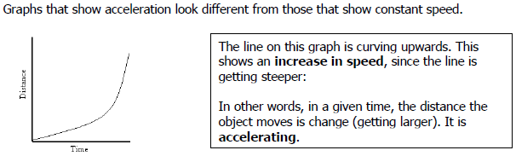

Summary
PRACTICE
Examine the graphs below to answer the questions.
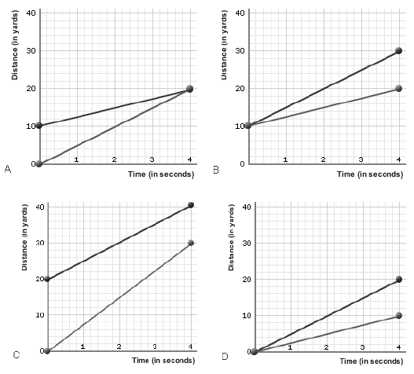
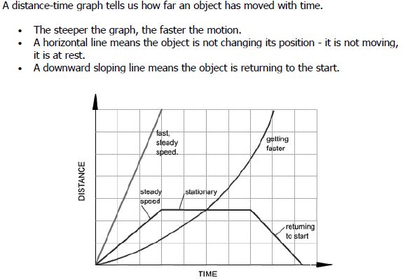
- Which of the graphs shows that one of runners started 10 yards further ahead of the other? Explain your answer.

- In which of the graphs are both runners moving at the same speed? Explain your answer.

- Compare and contrast the runners in graphs A and D.

- If you were to calculate the slope of the lines shown in the position vs. time graphs, what would it give you? (I’m NOT asking you to actually

