Macromolecules – Proteins
Proteins
- Amino Acids
- Functions of proteins and examples | 1.  2.  3.  4.  5.
- Structure of Amino Acids | 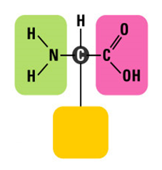
- Elements found in all proteins
- Four levels of protein structure | -Primary Structure  -Secondary Structure  -Tertiary Structure  -Quaternary Structure  PROTEIN SHAPE AFFECTS ITS FUNCTIONS!
- Denaturing Proteins

