**The Effect of whether the Cart is pushed Up or Down on the Ramp on the Acceleration of the Cart**

Design:

Research Question- How does whether you push the cart up the ramp or down the ramp affect its acceleration?

Hypothesis- I believe that when you push the cart up the ramp it will have a positive acceleration because the cart has to work against gravity to move upwards, so it will be slowing down. At the same time it is moving in the opposite direction and will have a negative velocity, so both of those factors combined should result in a negative acceleration. On the other hand I believe that if the cart moves down the ramp it will have a positive acceleration because it will be gaining speed with the help of gravity pushing it down, and at the same time it will be moving in a positive direction and have a positive velocity.

Variables- The independent variable of this experiment is whether or not you push the cart up the ramp or let it fall down the ramp. The dependent variable is the acceleration of the cart. The constants of this experiment include the angle of the ramp, the cart used, the force applied to the cart when pushing it up, and the timer used.

Procedure- First we set up the ramp on level ground and hooked up the pathway on the twelfth rung. We placed the cart at the bottom of the ramp and placed the photogates in two random locations; we chose to start out with 30 centimeters and 60 centimeters. We attached one wire from the first photogate (the one closest to the bottom) to the “A” part of the timer and the second wire to the second photogate (the one closest to the top) to the “B” part of the timer. Then, with a consistent force that we apply when running the rest of the trials, we pushed the cart up the ramp. Someone caught the cart at the top and another person recorded the times for A, B, and the time passed from A to B. To do this we pressed the A button to see the B time, the B button to see the A time, and pressed both to see the time from A to B (when the light is on over A it shows the A time and vice versa with B, and when both lights are on it shows the time from A to B). Then we switch the wires on the timer, reset the timer, and release the cart from the top. Someone held the bottom of the ramp so that it wouldn’t shake and mess up the data. We then recorded that data in a separate chart made specifically for when the cart when down the ramp. We then switched the wires on the timer and reset it again to push the cart back up. We repeated this twice for both pushing the cart up and letting it roll down before setting the photogates in two different positions and repeating this process. We did this for five total positions.

Data Collection and Processing:











I chose to separate the raw data into two charts: one for pushing the cart up and one for it falling down. If they were combined the chart would have been too large and confusing. I then made one chart for the averages because they were necessary in finding the velocity, which was necessary in finding the acceleration. To accurately show acceleration in my graph I made the x-axis the average time from A to B and the y-axis the final velocity.

Sample Calculation-

Position: 40-75 centimeters going down ramp

A average: (0.0604 + 0.099 + 0.086) / 3 = 0.0818 seconds

B average: (0.0276 + 0.0293 + 0.029) / 3 = 0.0286 seconds

A to B average: (0.2804 + 0.3535 + 0.3333) / 3 = 0.3224 seconds

Velocity of A: 5/ 0.0818 = 61.125 cm/second

Velocity of B: 5/ 0.0286 = 174.825 cm/second

Acceleration: (174.825 - 61.125) / 0.3224 = 352.667 cm/s/s

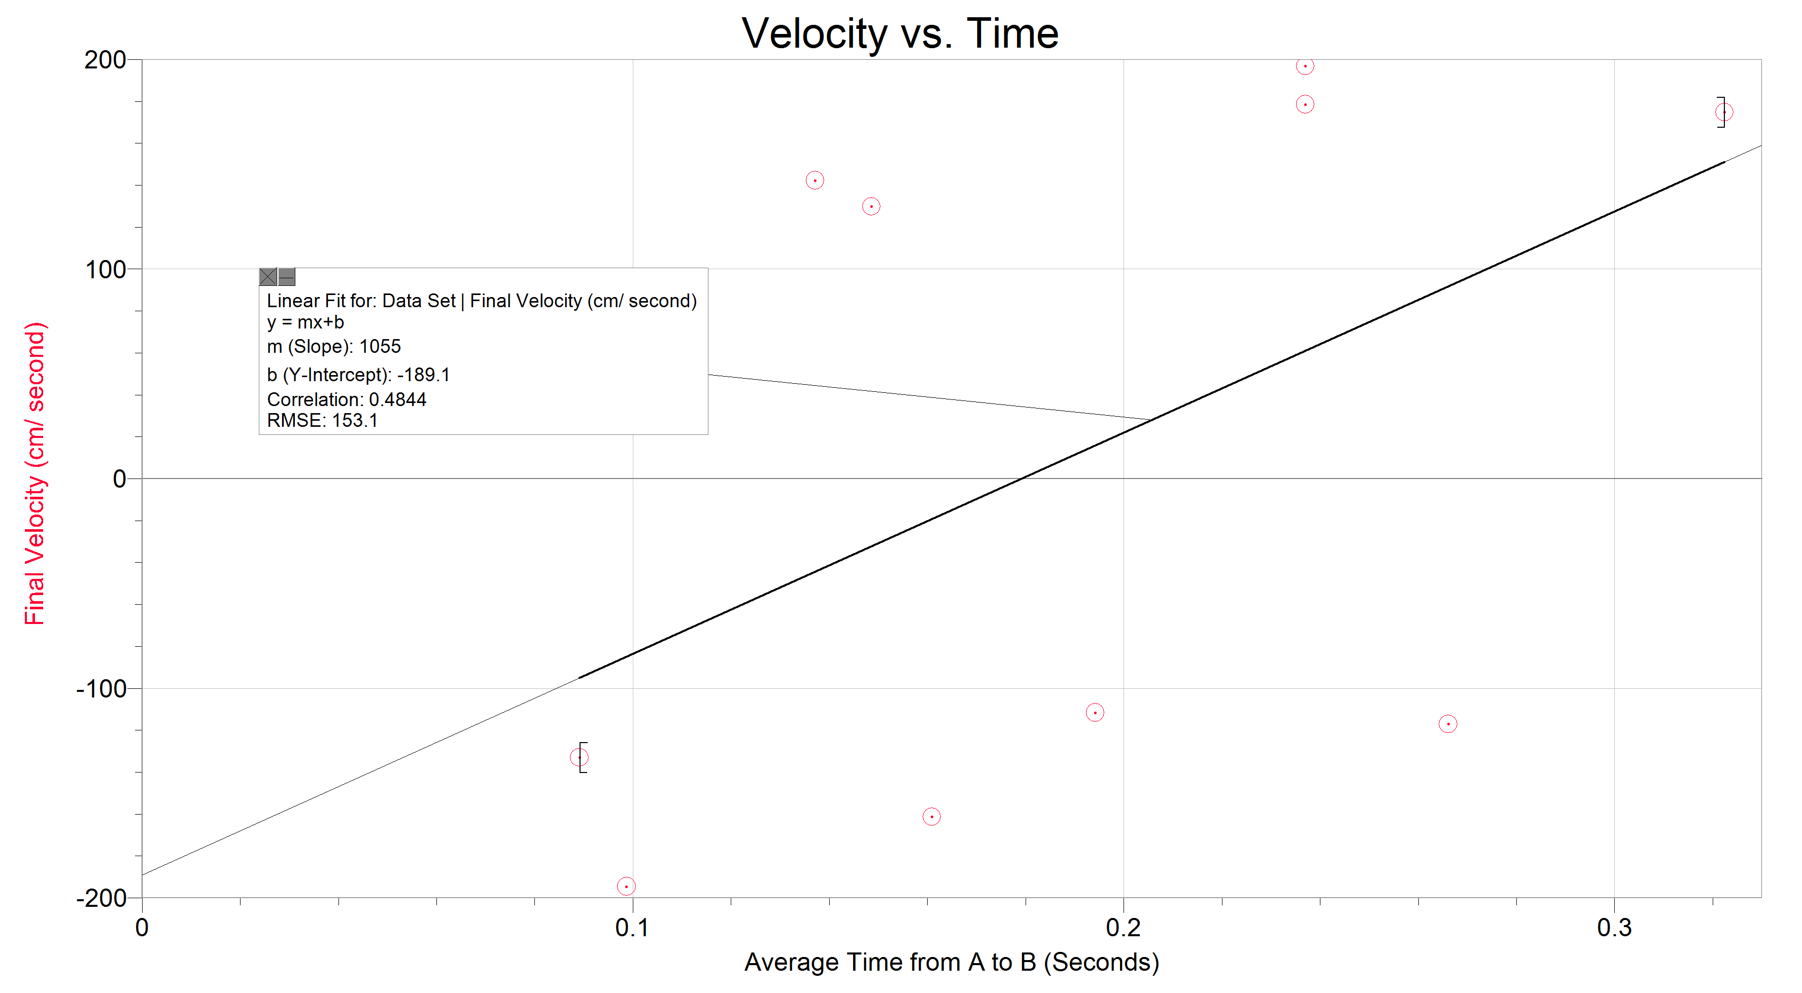

Conclusion and Evaluation:

In the end the results of my experiment supported my hypothesis. The accelerations for the cart moving up and down both ended up being positive. While the velocity for the cart going up started out being negative, the process of finding the acceleration included subtracting the final velocity from the initial velocity, which resulted in a positive number. There were several limitations with this experiment, the main one being the force at which we pushed the carts going up the ramp. Since we’re human we can’t accurately exert the same amount of force for each trial, so the numbers weren’t as precise as they could have been. Also, since there were so many charts and calculations involved in this particular experiment, it’s possible that a few numbers could have been switched up in the process (specifically referring to the outlier for the acceleration of the cart being pushed up the ramp at 20-55 centimeters). Overall, however, the process was simple and the results revealed what was expected. If I had to do this project again I would have one person push the cart up every time and make a point to have them push the cart so that it reached a specific point on the ramp (that way the force would be more consistent). I would also create all of the charts ahead of time so I could simply fill them in as I went along instead of getting half of the numbers and getting the rest from my teammates (the combination of rushing and discerning handwriting could have resulted in some incorrect numbers).