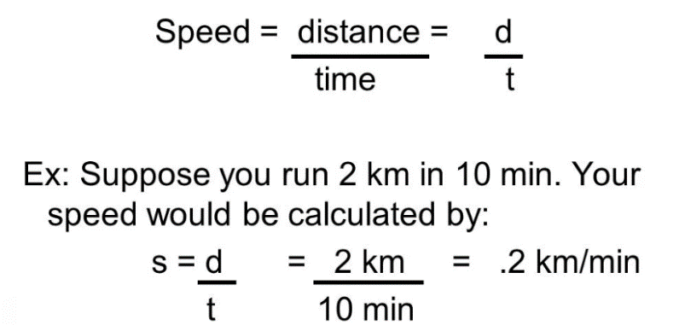
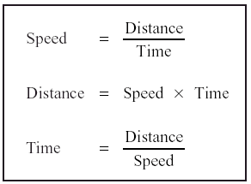
Speed Calculations Reinforcement
Name:

- Jane drives at an average speed of 45 mph on a journey of 135 miles.
How long does the journey take?

- Chris cycles at an average speed of 8 miles per hour. If he cycles for 6.5 hours, how far does he travel?

- Nikki has to travel a total of 351 miles. She travels the first 216 miles in 4 hours. What is her average speed for the first part of the journey?

- Calculate the speed of the object between points A and B. The time between every dot is 2 seconds. SHOW YOUR WORK!
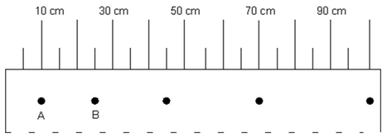
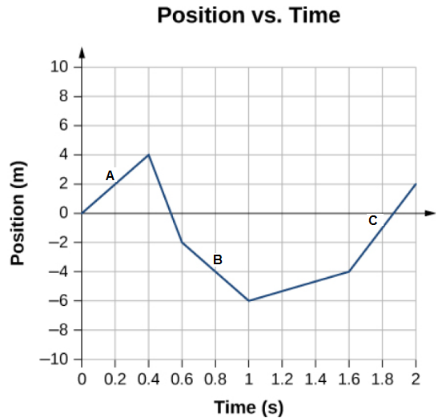

- Calculate for speed the speed at A.

- Calculate for the speed at B.

- Calculate for the speed at C.

- Which segment is showing the object moving the fastest?

