Test Review Bell Ringer
Name:
- How much does a 3.0 kg bag of bolts weigh?

- The figure below shows a block that is being pulled along the floor. According to the figure, what is the acceleration of the block?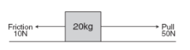

- Calculate the momentum of a 10 ton elephant traveling at a speed of 5m/s.

- What is the missing force in the figure diagram below? Hint: acceleration is 0 N.

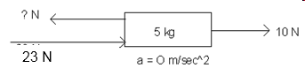

Test Review Bell Ringer
Name:
- How much does a 3.0 kg bag of bolts weigh?

- The figure below shows a block that is being pulled along the floor. According to the figure, what is the acceleration of the block?

- Calculate the momentum of a 10 ton elephant traveling at a speed of 5m/s.

- What is the missing force in the figure diagram below? Hint: acceleration is 0 N.

