The Conservation of Momentum Procedures Copy

Go to www.gigaphysics.com, then go to Virtual Labs, and then click Conservation of Momentum.
Click New Experiment.

Part I: Measure the Carts
- Find the length of the purple cart, use your mouse to drag the cart over the caliper in the upper left corner of the lab. Convert the length to meters [cm ÷ 1000 = m] then record your result in the table. Repeat for the green cart.
- Find the masses of the carts by dragging each one in turn over the electronic balance in the upper right corner. The balance reads in grams, so convert kilograms [g ÷ 1000 = kg], then record your data.
Part II: Determine the Carts’ Velocities
- Select “same direction” from the Carts’ Direction menu and “inelastic” from the Collision Behavior menu.
- Click Start Carts to put the carts in motion. The red numbers you will soon see tell you how many seconds it took each cart to pass through that photogate. If you lose track of which photogate is measuring which cart, notice the purple and green arrows labelling each; a half purple/half green arrow is used when both carts were stuck together as they passed through. You can also click Start Carts if you want to watch the collision again.
- Record your times in the data table at the top of the next page. Also copy the lengths from part I. Be sure to add the lengths of the two carts when the carts are stuck together.
- Calculate each cart’s velocity and enter it in the table as well.
Part III: Calculating Momentum
- Use the fact that momentum = mass$•$velocity to calculate the momentum of each cart. Remember to add the masses when the carts are stuck together.
- Calculate the total momentum of the two carts before and after the collision.
Part IV: The Elastic Collision
- This time, set the Carts’ Direction to opposite and the Collision Behavior to elastic. Repeat the same steps as in part II and III.
- When you calculate the velocities and momentum, signs matter. Make sure that carts that are moving to the left have negative velocities. If you lose track of which direction the carts were going for each photogate, you have the arrows to help you, and you can click Start Carts to watch the collision again.
Part V: One More Case
- Repeat the experiment once more, this time with any combination of Carts’ Direction and Collision Behavior you have not used already. Record which settings you use, then complete the calculations as before.

The Conservation of Momentum Name __________________________

Part I: Measure the Carts
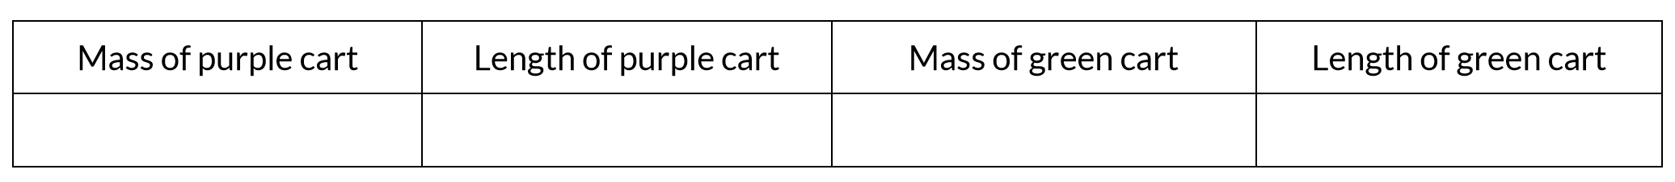
Part II: Determine the Carts’ Velocities
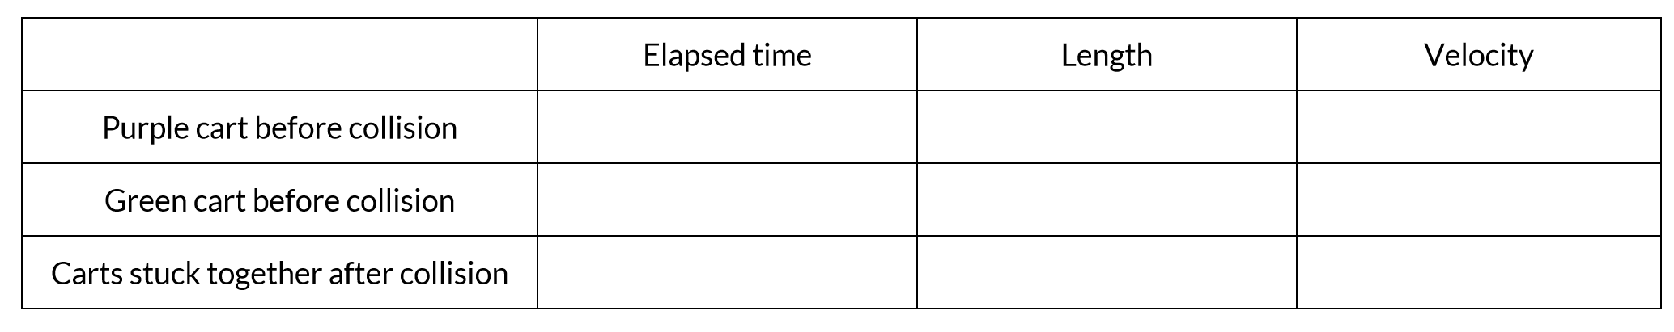
Part III: Calculating Momentum
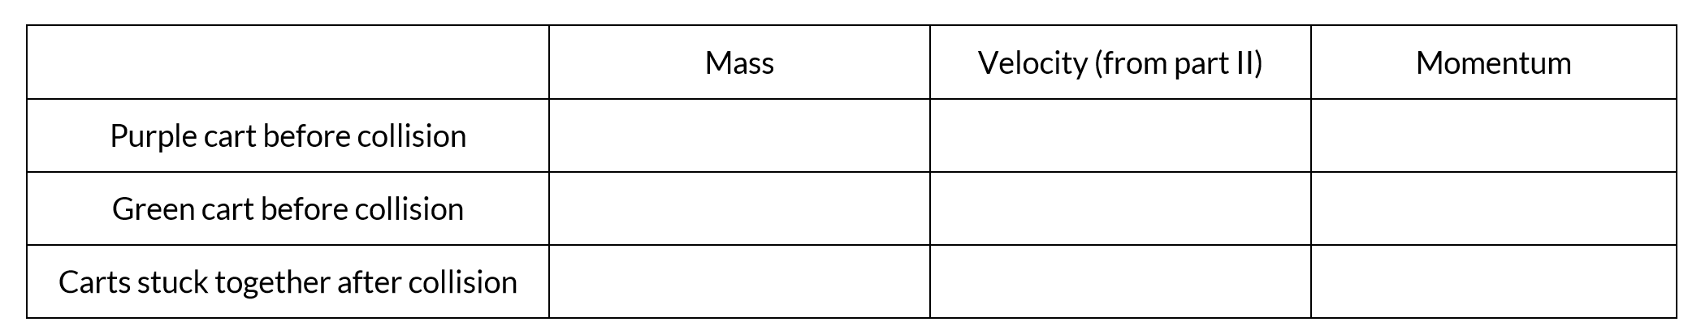
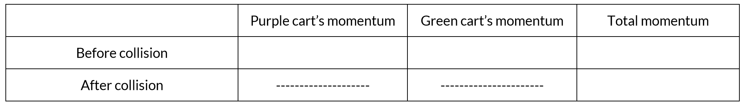
Part IV: The Elastic Collision
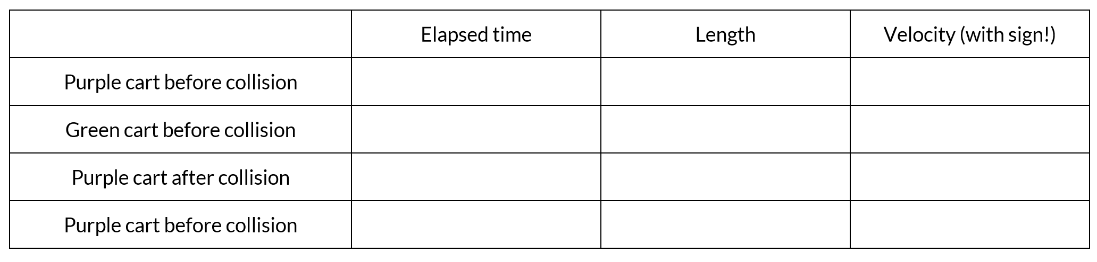

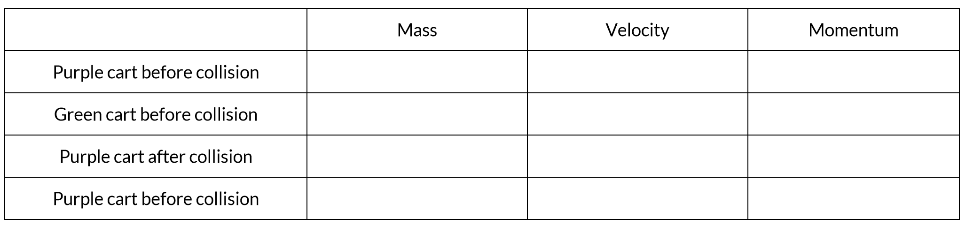
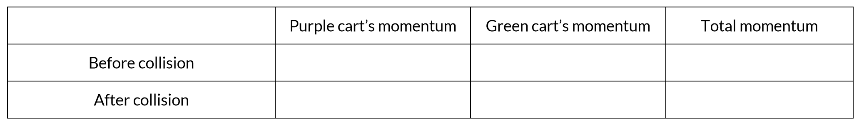
Part V: One More Case
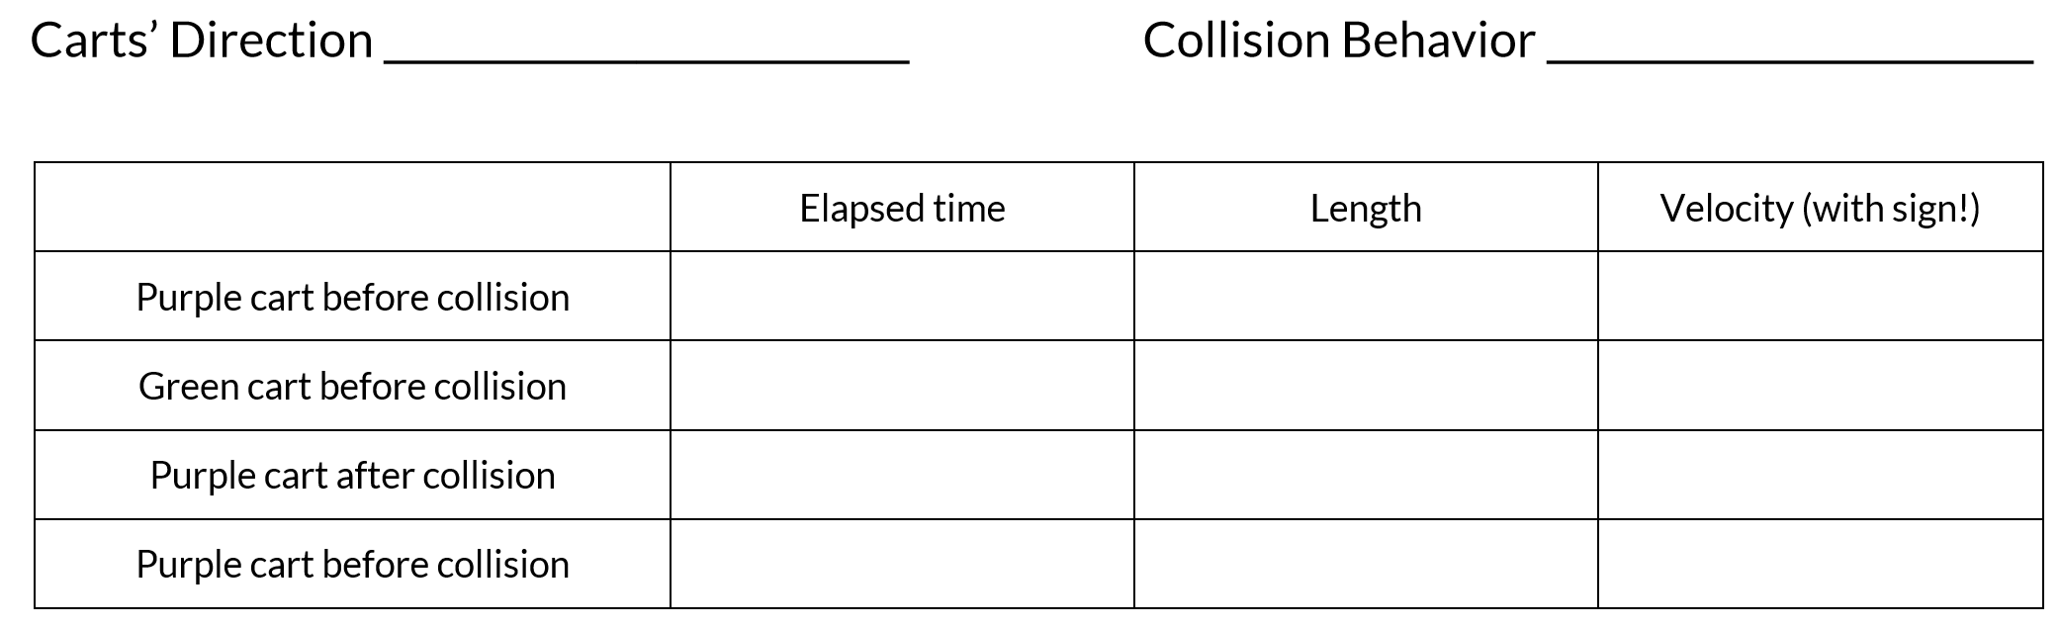
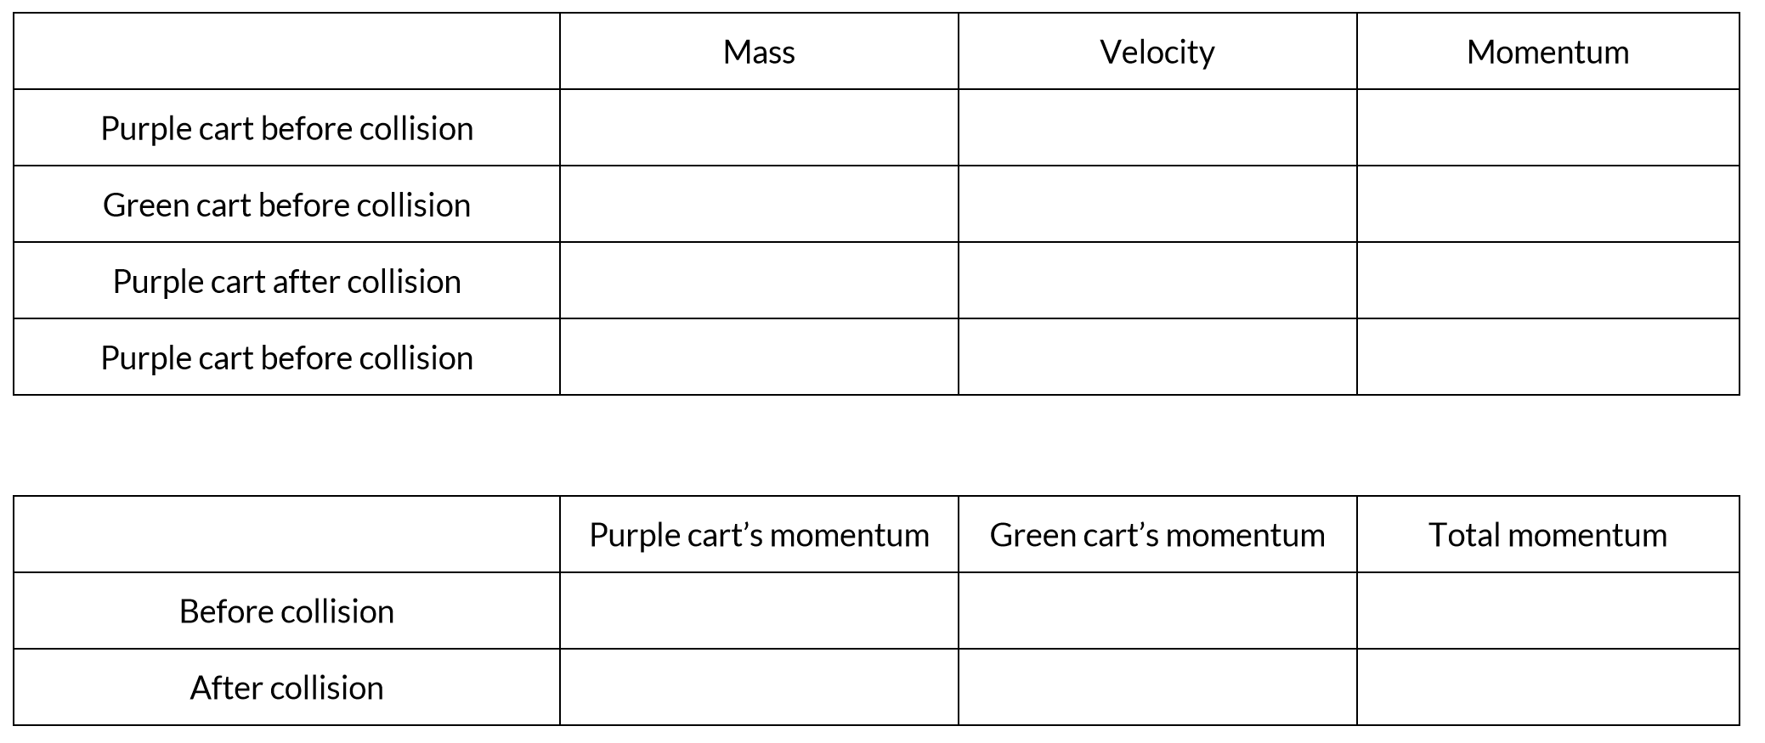

Write a conclusion that includes your findings about total momentum – Describe momentum. What do you think is most important in collisions – mass or velocity?

