Turtle Tracking Map
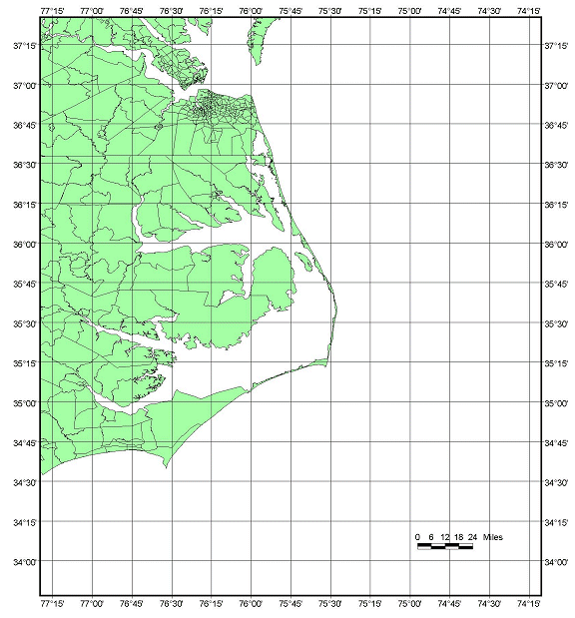
North
Carolina
Virginia

Turtle Data
When plotting data on map, you MUST number your points!!
Date | Time (GMT) | Latitude | Longitude | Reading
07/12/00 | 10:07:48 | 36°36’ | 75°54’ | 1
07/12/00 | 11:47:16 | 36°36’ | 75°54’ | 2
07/12/00 | 12:12:32 | 36°36’ | 75°54’ | 3
07/12/00 | 13:50:25 | 36°30’ | 75°49’ | 4
07/12/00 | 15:41:15 | 36°24’ | 75°42’ | 5
07/12/00 | 17:24:45 | 36°30’ | 75°54’ | 6
07/12/00 | 21:34:58 | 36°30’ | 75°48’ | 7
07/13/00 | 11:17:31 | 36°18’ | 75°48’ | 8
07/14/00 | 0:46:10 | 36°24’ | 75°24’ | 9
07/14/00 | 1:17:48 | 36°12’ | 75°30’ | 10
07/14/00 | 7:59:52 | 36°6’ | 75°54’ | 11  Facts about the Satellite Turtle:  Species: Loggerhead (Caretta caretta)  Gender: Adult Female  Carapace Length: 93.1 cm  Date Found: July 11, 2000, 10:25 PM  Number of Eggs Laid: 119  Flipper Tag: XXF-853 applied to left front flipper
07/14/00 | 10:52:47 | 36°6’ | 75°42’ | 12
07/14/00 | 11:33:03 | 36°6’ | 75°30’ | 13
07/15/00 | 11:15:31 | 35°54’ | 75°36’ | 14
07/15/00 | 20:54:39 | 36°6’ | 75°42’ | 15
07/15/00 | 22:25:38 | 35°54’ | 75°30’ | 16
07/17/00 | 14:34:14 | 35°30’ | 75°42’ | 17
07/17/00 | 20:33:57 | 35°36’ | 75°24’ | 18
07/18/00 | 1:01:55 | 35°30’ | 75°24’ | 19
07/18/00 | 3:47:15 | 35°30’ | 75°42’ | 20
07/18/00 | 8:57:24 | 36°30’ | 75°24’ | 21
07/18/00 | 11:42:15 | 35°30’ | 75°30’ | 22
07/20/00 | 14:18:29 | 35°30’ | 75°18’ | 23
07/22/00 | 2:58:05 | 35°36’ | 75°30’ | 24
07/22/00 | 12:49:04 | 35°30’ | 75°24’ | 25
07/23/00 | 8:04:14 | 35°30’ | 75°24’ | 26
07/24/00 | 9:26:25 | 35°30’ | 75°24’ | 27
07/26/00 | 1:23:01 | 35°30’ | 75°24’ | 28
07/26/00 | 16:04:12 | 35°30’ | 75°24’ | 29
07/26/00 | 23:21:16 | 35°30’ | 75°30’ | 30
07/30/00 | 1:32:23 | 35°30’ | 75°24’ | 31
07/30/00 | 21:08:34 | 35°30’ | 75°24’ | 32
07/30/00 | 23:29:36 | 35°30’ | 75°24’ | 33
07/31/00 | 1:08:38 | 35°30’ | 75°24’ | 34
07/31/00 | 11:51:00 | 35°30’ | 75°18’ | 35
08/02/00 | 10:59:16 | 35°30’ | 75°30’ | 36
08/03/00 | 1:56:29 | 35°30’ | 75°24’ | 37
08/03/00 | 9:12:00 | 35°48’ | 75°24’ | 38
08/03/00 | 10:54:09 | 35°36’ | 75°24’ | 39
08/03/00 | 12:15:49 | 35°12’ | 75°12’ | 40
08/04/00 | 20:19:08 | 35°30’ | 75°42’ | 41
08/05/00 | 10:29:46 | 35°24’ | 75°24’ | 42
08/07/00 | 1:03:21 | 35°24’ | 75°24’ | 43
08/07/00 | 12:33:42 | 35°24’ | 75°36’ | 44
08/09/00 | 9:20:07 | 35°24’ | 75°30’ | 45
08/10/00 | 0:41:28 | 35°24’ | 75°18’ | 46
08/10/00 | 10:33:13 | 35°24’ | 75°54’ | 47
08/11/00 | 12:43:07 | 35°18’ | 75°6’ | 48
08/12/00 | 1:44:22 | 35°30’ | 75°18’ | 49
08/13/00 | 10:36:27 | 35°18’ | 75°24’ | 50
08/13/00 | 13:37:09 | 35°12’ | 75°24’ | 51
08/13/00 | 20:20:00 | 35°0’ | 75°24’ | 52
08/13/00 | 20:51:47 | 35°12’ | 75°18’ | 53
08/13/00 | 22:32:10 | 35°12’ | 75°48’ | 54
08/13/00 | 23:14:00 | 34°54’ | 75°24’ | 55
08/14/00 | 10:44:24 | 34°36’ | 75°48’ | 56
08/15/00 | 12:01:31 | 35°0’ | 75°54’ | 57
08/15/00 | 16:47:12 | 35°6’ | 76°6’ | 58
08/15/00 | 21:40:31 | 34°54’ | 76°24’ | 59
08/15/00 | 21:40:31 | 34°54’ | 76°6’ | 60
08/16/00 | 8:17:56 | 34°54’ | 76°24’ | 61
08/16/00 | 11:36:21 | 34°36’ | 76°0’ | 62
08/16/00 | 19:45:57 | 34°48’ | 76°18’ | 63

