Universal Gravitation Lab
Purpose:
In this activity you will be learning how the distance between objects affects the force of gravity between the objects.
Info: Make sure you measure distance from center of mass 1 to center of mass 2
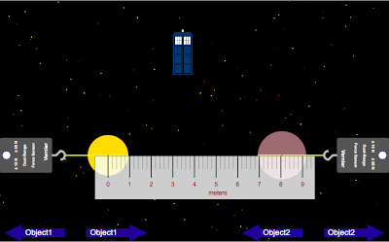
Part 1: Distance
- Open the Universal Gravity Lab [link provided on assignment]. If you hold down the command key as you click, it will open the program in a new window.
- Set up object 1 and object 2 [click on Object 1 & Object 2 at the top to do this] to any factors that you want, but once they are set, you cannot change them for the remainder of part 1.
- Turn on the ruler so you can get the distance between the centers of object 1 and object 2.  - Move the objects around test 10 different distances apart and record the distance and the corresponding force (be sure to write the force using the same metric prefix the whole time). Click Force at the top to get your data.  - Create the data table to the right on a word document.  - Fill in your data table as you work with the animation. | Distance (m) Force (N)

- Graph your data in Logger Pro. Then click Analyze, Curve Fit and select "inverse squared" as your graph type.
- When you add the “inverse squared” on your graph, you are applying the Inverse Square Law. We will get into this later
- Copy your graph onto a Word Document. Be sure to title the graph AND write the relationship of the graph below it.

Part 2: Mass 1
- Set up object 2 to any factors that you want, but once the factors are set, you cannot change them for the remainder of part 2.
- Set your distance between the centers of the two masses. Do not change this for the remainder of part 2.
- Change around the mass of object 1 and record the corresponding forces between the objects. Do at least 5 different masses. Make sure you make a chart to track your data on your Word Document.
- Graph your data, copy graph onto Word Document, and write the relationship in a sentence.

Make sure all of this is done on ONE word document and labeled part I and part 2. You will be saving you word document onto my flash drive when you are done!!

