Universal Gravitation Lab
https://www.thephysicsaviary.com/Physics/Programs/Labs/UniversalGravityLab/index.html
Purpose:
In this activity you will be learning how the distance between objects affects the force of gravity between the objects.
For DISTANCE:  Make sure you measure distance from center of mass 1 to center of mass 2  For MASS:  Numbers may be in scientific notation. Example | 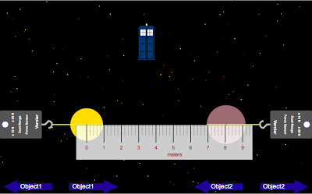  What does this mean?  1.75 x 10³ = 1750 kg
Part 1: Distance
- Open the Universal Gravity Lab [link provided on my website] and open up Excel.
- On the Universal Gravity Lab, set up object 1 and object 2 [click on Object 1 & Object 2 at the top to do this] to any factors that you want, but once they are set, you cannot change them for the remainder of part 1.
- Turn on the ruler so you can get the distance between the centers of object 1 and object 2. Remember to measure from the centers!!  - Move the objects around and test 10 different distances apart. Record the distance and the corresponding force (be sure to write the force using the same metric prefix the whole time). Click Force at the top to get your data.  - Create the data table to the right on your excel spreadsheet.  - Fill in your data table as you work with the animation. | Distance (m) Force (N)
- Graph your data in Excel. Remember to highlight your data table, click on insert, then click on scatter plot (this is the same graph you used for the last lab we did on excel!)
- Make sure to add a title to your graph as well as label your axis. Do this by clicking on the green plus sign next to your graph.
- You will then need to add a trendline to your graph as well.
- Copy and paste your data table and graph onto a word document!
- In 1-2 sentences, explain what your graph is showing about the relationship between force and distance.
- Label this section Part 1. Also, make sure to include your name on the word document as well.
Part 2: Mass 1
- Set up object 2 to any factors that you want, but once the factors are set, you cannot change them for the remainder of part 2.
- Set your distance between the centers of the two masses. Do not change this for the remainder of part 2.
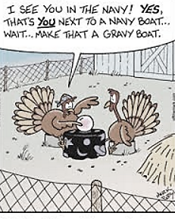
- Change around the mass of object 1 and record the corresponding forces between the objects. Do at least 8 different masses. Make sure you make a data table to collect your data on Excel and fill it in as you go along.
- Graph your data using excel (just like in part 1), copy your data table and graph onto your word document.
- Write a 1-2 sentence explanation as to what the relationship is between mass and force.
- Make sure to label this sections Part 2.

Make sure your name is on the word document and print it off!

