Velocity vs. Time Graph Reinforcement
Name:
A horizontal line on the V-T graph means constant velocity.
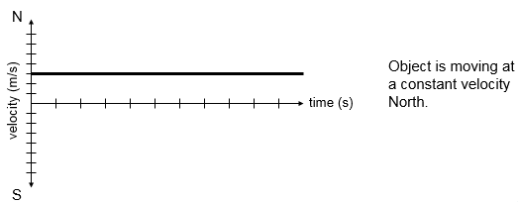
- A velocity-time (V-T) graph shows an object’s velocity as a function of time.
  - A horizontal line = constant velocity.
  - A straight sloped line = constant acceleration.
    - Acceleration = change in velocity over time.
  - Positive slope = positive acceleration.
    - Not necessarily speeding up!
If an object isn’t moving, its velocity is zero.
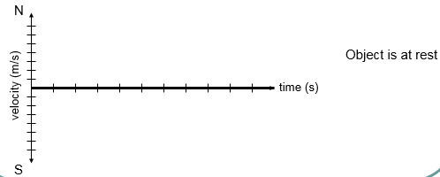
  - Negative slope = negative acceleration.
    - Not necessarily slowing down!

- If the V-T line has a positive slope, the object is undergoing acceleration in positive direction.
V-T graph has positive slope.
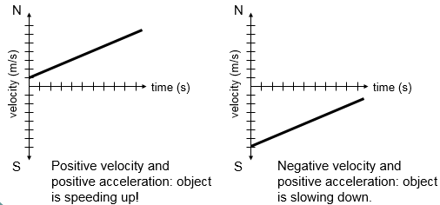
  - If v is positive also, object is speeding up.
  - If v is negative, object is slowing down.

- If the V-T line has a negative slope, the object is undergoing acceleration in the negative direction.
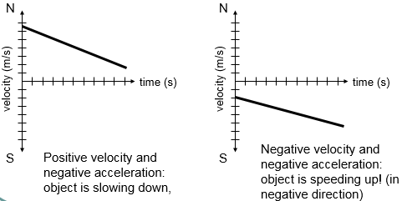
  - If v is positive, the object is slowing down.
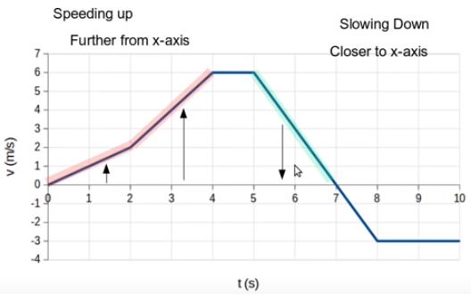
  - If v is negative also, the object is speeding up.

Use the graph below to fill out the data table.
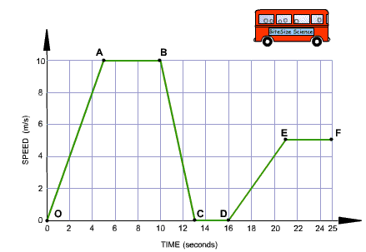
Scenario | Segments
Moving at a constant speed
Speeding up
Slowing down
Not moving at all

