Waves Notes

**Dissection:** 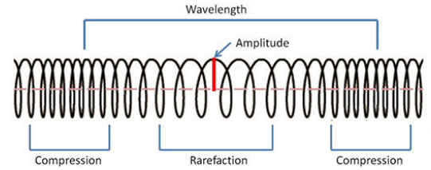

**Dissection:**

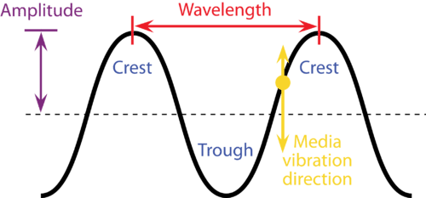

**Examples:**

**Examples:**

**Type:**

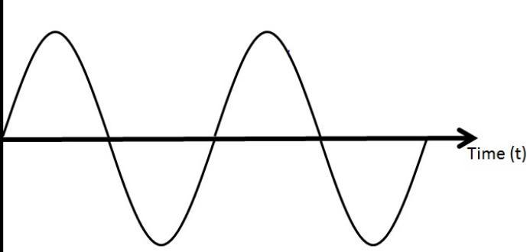

**Type:**

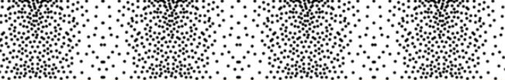

Waves Basic Info and Definitions

* Waves transport _________________________________energy over great distance

Trough:

Crest:

Wave Speed:

Wavelength:

Amplitude:

Frequency: